Once Upon A Workshop
Charles Taliaferro (St. Olaf College)

Once upon a workshop, cheery, while we pondered, neither weak nor weary, over many an argument and...... For some reason on Tuesday morning, Edgar Allen Poe was on my mind as I stumbled across campus at St. Olaf College to take part in a workshop with six intimidating colleagues. Why Poe? Why were the colleagues intimidating? I eventually figured out why Poe was in my thoughts (more on this in a bit) but as for intimidating colleagues: Have you heard of the London School of Economics or Yale or Oxford or done studies on amputees in America or done major work in theatre or done a close study of corpses and ghosts in early English literature or ... It may have been a mistake to have read the work of those I was going to work with for three days. Worse, I was sort of, well, to use a word seldom on my lips, supposed to "lead" or "direct" (or something like that) the workshop. What can one possibly say to a fellow faculty member who has published in the Journal of Chemistry Education --when you don't know enough contemporary chemistry to write something that would be rejected by the editors of the journal after they read the title? Maybe Paul Jackson does not know everything (I told myself); for example, maybe he does not know that the average person breathes 25,000 times a day. But how could I possibly work that into a conversation?

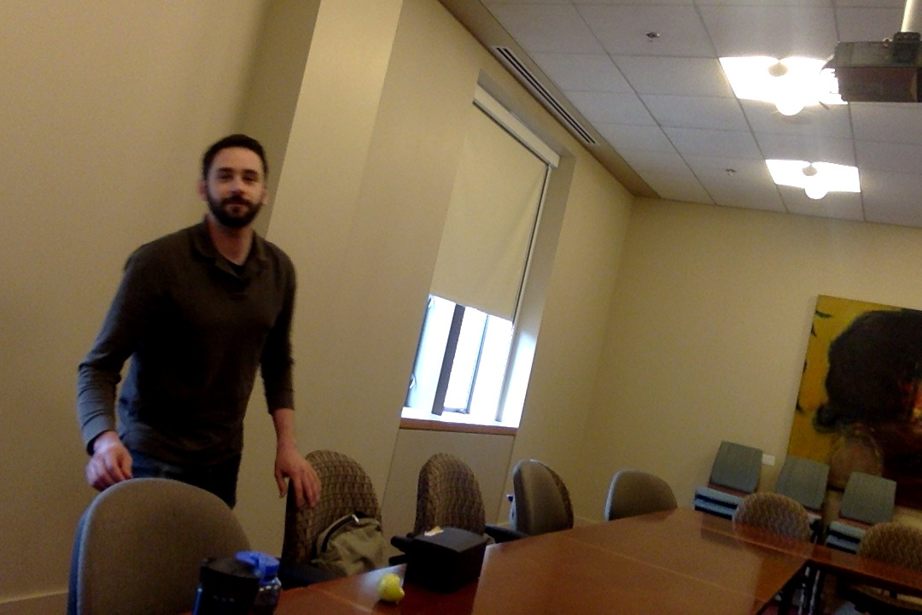
I was not exactly relieved in meeting an economics professor whom I greeted in what was to be the site of the workshop with a Middle Eastern custom of placing my right hand on my heart and bowing slightly. I think he said something about not returning (or not feeling comfortable returning) the gesture. And why shouldn't he? I had come back from Iran and picked up the custom, but why in the world would I start off trying to become friends with Seth or anyone with talk of being self-conscious about greeting people? A thought dawned on me with a clarity and conviction that was virtually irrefutable: "It's true. I really am an idiot." We talked about Seth's time in New Haven, London, graduate schools, and gradually I got to know of my other colleagues: Karen's time in theatre, her love for philosophy and thinking about law school until she encountered a lawyer who spent most of his days in an office, by himself, surrounded by books. As we introduced ourselves and our topics of interest, Ashley spoke about the difference between students professing some values (for example, they would not want to be lied to by a physician if they wanted to know whether they were terminally ill) but they were not prepared to put those values into practice (for example, few of the students who did not want to be lied to would be comfortable, if they were the doctor, telling the truth to terminally ill patients). Each person --Karen M, Karen W, Paul, Jason, Seth, Ashley-- seemed bathed in intelligence, not the cloying, imperious haughty kind, but the intelligence that is held and demonstrated with humility, a light touch, a hint of self-deprecation... the kind of intelligence that might get people to breathe 50,000 times a day. Given that most in attendance were younger than me, I decided that I could not count on familiarity with the film "The Graduate" and the line, delivered brilliantly by Dustin Hoffman "Mrs. Robinson, are you trying to seduce me?" but if that familiarity was there, I would have tried to imitate Dustin Hoffman's voice in saying something like: "Ashley, Seth, Karen, Karen, Paul, Jason...are you trying to make me wish I had been a / an [Economics / Chemistry / literature / theatre / Canadian major or citizen]?

I feel sure most of us know what it is like to be in a room when the energy or charm or fascination comes from tales about other rooms or remote places. "Your story is good," someone might say "but you should have been there when I was at Princeton University [you HAVE heard of PRINCETON, right?] when......." The message is: HERE is less interesting than THERE and BACK THEN is more interesting than HERE AND NOW. Over three days, we did share tales of older times and other places. But our seminar room became itself a site for energy or charm or fascination (in my view) when , for example, Seth pointed out that in a statement I made about not being judgmental, that I was being judgmental (he was right, of course) or when Jason "outed" me as a craven spirit when he said something like: "If there was a public execution of someone in Northfield, I know that Charles would go to watch it." I found myself agreeing that this was true, temporarily forgetting that I at least claim to have serious religious objections to capital punishment. And I believe we worked well together struggling with real world projects (how might one impact negligence in medical practitioners?) and how to think about difficult things (accounts of child abuse).

I believe it was Poe who said something like evil is a consequence of goodness; you would not have certain sorrows --such as regretting the loss of joy-- unless you had some good or promise of goodness such as the pure joy in the presence of a new friend or friends. No one would agonize over the failure to be ecstatic unless one had some experience or taste or yearning for the ecstatic. Maybe it was under the spell of Poe, that we discussed the importance of being motivated more by the love of the good (or love of justice, love of health) rather than by hatred of what is bad (the hating of disease or illness or injustice). In any case, over three days I had more than one moment of joy, maybe even something that approached ecstasy and I do feel some sorrow about not getting in the car and continuing the workshop. One moment or more of joy was prompted by a note of thanks from one participant which I have now re-read about five times. Another was at the very end of the third day.

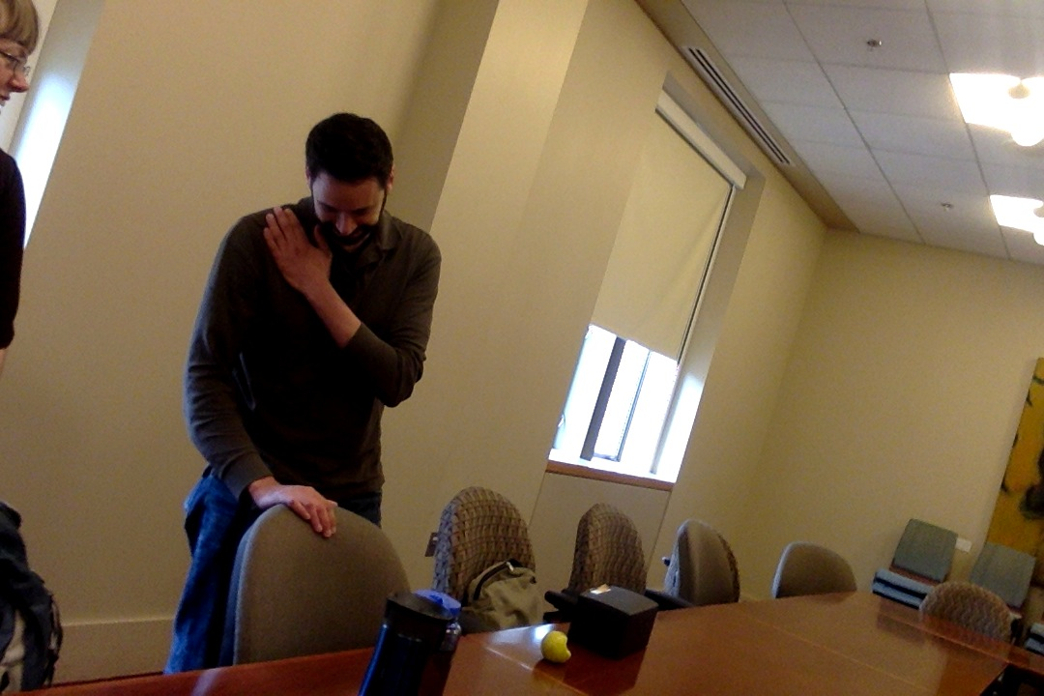
Seth placed his right hand over his heart and bowed slightly. It was a moment I had to record (see below). Keep in mind, as you glance at the two images (if you have read this essay this far, that is!) that I am the sort of person who would, if I were selling superhero outfits, add a warning label like: "Wearing this garment does not enable you to fly." So, in sharing these images I suppose I should add that looking at them may not enable you to fly, but looking at them might. And if you don't exactly, that is literally fly, it may give you joy.

