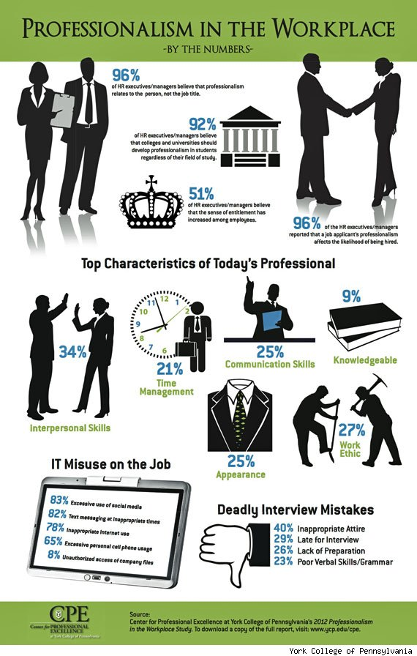COLLEGE GRADS LACKING PROFESSIONALISM IN THE WORKPLACE
by BRITTANY TROYER on MAY 30, 2012
Generation Y is accustomed to a much more lax atmosphere where sending text message-like emails from their smart phones is second nature. Recent grads are becoming more laid back, but their future workplace may not be.
The job market is as competitive as ever. As recent college graduates have looming school loans over their heads there is no better time to avoid the common mistakes of the rest of the Gen Y’ers vying for the same positions.
The 2012 “Professionalism in the Workplace Study” surveyed a national sample of HR professionals, upper class undergraduates, and managers or supervisors. The study helped to define professionalism and provide numbers to analyze the current state of professionalism in the American workforce.
It is important for recent graduates to take in to account the qualities most sought after by their next interviewer.

From an HR standpoint, the most essential qualities of professionalism are listed below:
- Interpersonal skills (33.6%)
- Appearance (25.3%)
- Communication skills (24.9%)
- Time management (20.8%)
- Confidence (20.7%)
- Ethical (15.2%)
- Work ethic (14.2%)
- Knowledgeable (9.3%)

Now, how are recent graduates lacking in professionalism? Here is how Generation Y’s habits and lifestyle are conflicting with their Generation X employers:
- The obsession with technology is hindering recent hires and their ability to maintain a strong, qualified presence on the job. The study reported 83% of new hires excessively utilizing social media at work.
- Furthermore, 82% text at inappropriate times during the day.
- Lastly, the most common interview mistake of recent graduates is inappropriate attire at 40%.

