Staff Performance Annual Review

Employee Name: Employee ID:
Supervisor Name:
Fiscal Year review period: FY 26-27 (July 2026 to June 2027) Date of Review:

Goals and Objectives: List you 3-5 goals for the coming year (including note about timeline and expected outcomes). Set goals and objectives by July 2026 and complete by June 2027.

Goals are an achievable outcome that is broad and long-term. Objectives define measurable actions in the short term to achieve the goal. This can include professional development goals, if applicable.

1.

2.

3.

4.

5.

Employees Review of Goals and Objective’s Performance

Supervisor’s Review of Goals and Objective’s Performance

Competencies:
With the following competencies, please use the following rankings: (to be completed during review process in Spring 2027)
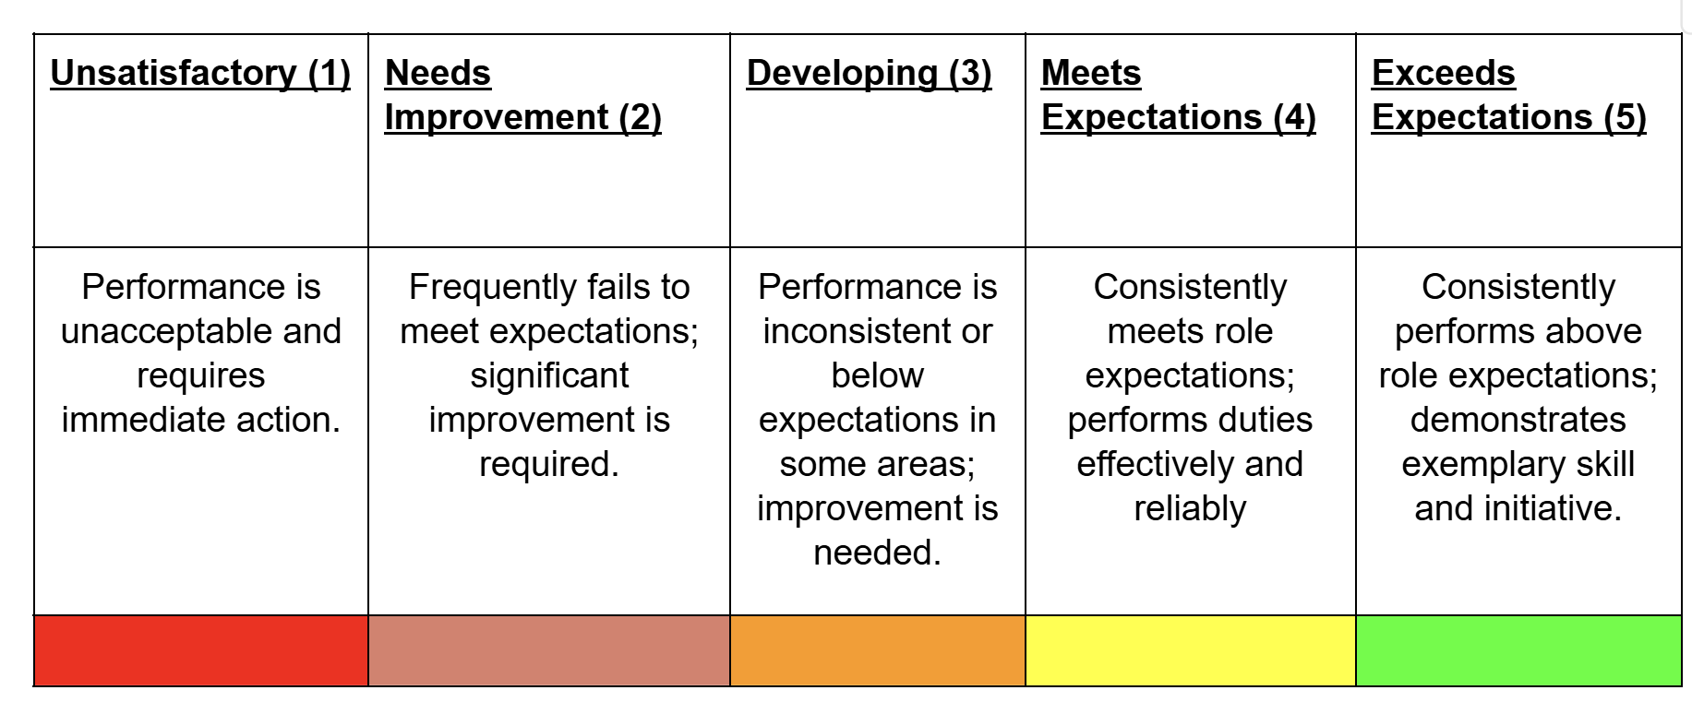
Employee Ratings:
Role Expectations:
1. Consistently meets job responsibilities and expectations
2. Produces accurate and quality work
Team Expectations:
1. Effectively communicates with others
2. Actively shares ideas, offers helps and takes initiative
College Expectations:
1. Treats others with Civility and supports an inclusive campus environment
2. Demonstrates the commitment to serving students, faculty, staff, and visitors with professionalism and care
Supervisor Ratings:
Role Expectations:
1. Consistently meets job responsibilities and expectations
2. Produces accurate and quality work
Team Expectations:
1. Effectively communicates with others
2. Actively shares ideas, offers helps and takes initiative
College Expectations:
1. Treats others with Civility and supports an inclusive campus environment
2. Demonstrates the commitment to serving students, faculty, staff, and visitors with professionalism and care

Supervisors Feedback on Goals and Competencies:
Overall Performance Rating

Additional Comments (Strengths? Improvements?)

Employee Signature: _______________________________ Date: _______________________________
Supervisor Signature: _______________________________ Date: _______________________________

