CLASSICAL MOVEMENTS PRESENTS
ST. OLAF CHOIR & ST. OLAF ORCHESTRA
ON JOINT TO UR OF NORWAY
JUNE 2-14, 2019

ANTON ARMSTRONG & STEVEN AMUNDSON CONDUCT 10 CONCERTS:
OSLO, STAVANGER, BERGEN, TRONDHEIM, LARVIK, HAUGESUND, ALESUND, KRISTIANSUND, VOSS, NORDFJORDEID

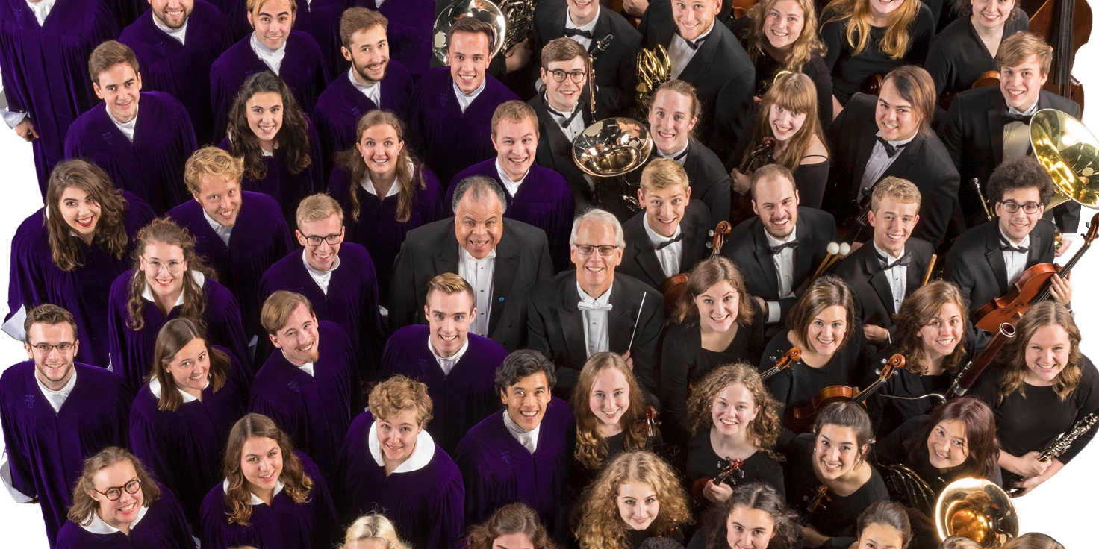

The world-renowned St. Olaf Choir and St. Olaf Orchestra of Northfield, Minnesota will return to Norway this summer for 10 exciting performances all across the country. This is their first joint visit since 2005, when the ensembles toured the country to celebrate the centennial of Norwegian independence.
Founded in 1874 by a group of pioneers that included Norwegian immigrants and affiliated with the Evangelical Lutheran Church in America, St. Olaf College is named after the King and Patron Saint Olaf II of Norway.
Presented by Classical Movements from June 2-14, 2019, the combined forces of the St. Olaf Choir and the St. Olaf Orchestra will share the stage during four joint concerts in Oslo (Oslo Opera House), Stavanger (Stavanger Konserthus), Bergen (Grieghallen) and Trondheim (Nidarosdomen), in addition to solo concerts. Tickets are available at stolafnorwaytour.no.

Directed by St. Olaf alumnus Anton Armstrong since 1990, the internationally acclaimed St. Olaf Choir will perform brand-new music by living Norwegian composers such as Ola Gjeilo and Kim André Arnesen, stirring arrangements of American spirituals by André Thomas and Moses Hogan and beloved choral works from masters such as Bach, Mendelssohn and Grieg.
Armstrong will lead the St. Olaf Choir—“a tour de force that brought the audience to its feet,” Washington Post—in four solo concerts: Larvik (Kulturhuset Bølgen), Haugesund (Vår Frelsers Kirke), Ålesund (Ålesund Kirke) and Kristiansund (Kristiansund Kirke).
Under the baton of Steven Amundson for more than 38 years, the award-winning St. Olaf Orchestra will perform an expertly curated program, highlighted by Samuel Barber’s Overture to The School for Scandal and Tchaikovsky’s Fifth Symphony, as well as John Williams’ scores from the Harry Potter films and Grieg’s own Norwegian Dances.
Amundson will conduct the St. Olaf Orchestra—“one of the best college orchestras in the nation,” Time Magazine—in two concerts of their own: Voss (Voss Kulturhus) and Nordfjordeid (Operahuset Nordfjord).

SCHEDULE:

June 2 Oslo Opera House, Oslo: St. Olaf Choir and St. Olaf Orchestra
June 3 Kulturhuset Bølgen, Larvik: St. Olaf Choir
June 5 Stavanger Konserthus, Stavanger: St. Olaf Choir and St. Olaf Orchestra
June 6 Vår Frelsers Kirke, Haugesund: St. Olaf Choir
June 7 Grieghallen, Bergen: St. Olaf Choir and St. Olaf Orchestra
June 9 Voss Kulturhus, Voss: St. Olaf Orchestra
June 11 Operahuset Nordfjord, Nordfjordeid: St. Olaf Orchestra
June 11 Ålesund Kirke, Ålesund: St. Olaf Choir
June 12 Kirkelandet Kirke, Kristiansund: St. Olaf Choir
June 14 Nidarosdomen, Trondheim: St. Olaf Choir and St. Olaf Orchestra

More information and tickets: www.stolafnorwaytour.no

ST. OLAF CHOIR PROGRAM:
Tentative and subject to change

KIM ANDRÉ ARNESEN
J.S. BACH
OLA GJEILO
GRIEG
MOSES HOGAN
MENDELSSOHN
ANDRÉ THOMAS
Live from Nidaros Cathedral in Trondheim, watch The St. Olaf Choir, conducted by Anton Armstrong, perform "Even When He Is Silent" by Kim André Arnesen

ST. OLAF ORCHESTRA PROGRAM:
Tentative and subject to change, soloist selections rotate on tour

MICHAEL ABLES, Delights and Dances for String Quartet and String Orchestra
Hanlon McGarity ’19, violin | Grace Kenny ’19, violin | Joshua Head ’20, viola | Sophia Spiegel ’19, cello
BARBER, Overture to The School for Scandal, Op. 5
ANDREW CANNESTRA, Flight
GRIEG, Norwegian Dance No. 1, Op. 35
MISSY MAZZOLI, These Worlds In Us
ARTURO MÁRQUEZ, Danzón No. 2
MOZART, Flute Concerto No. 1 in G major, K. 313, I. Allegro Maestoso
Noah Livingston ’19, flute
VLADIMIR PESKIN, Trumpet Concerto No. 1 in C minor, I. Allegro Con Fuoco
John Cloeter ’19, trumpet
TCHAIKOVSKY, Symphony No. 5 in E minor, Op. 64, IV. Andante Maestoso Allegro Vivace
JOHN WILLIAMS, “Hedwig’s Theme” from Harry Potter and the Sorcerer’s Stone
Live from St. Olaf College, watch the St. Olaf Orchestra, conducted by Steven Amundson, perform "Don Juan, Op. 20" by Richard Strauss

BIOGRAPHIES:
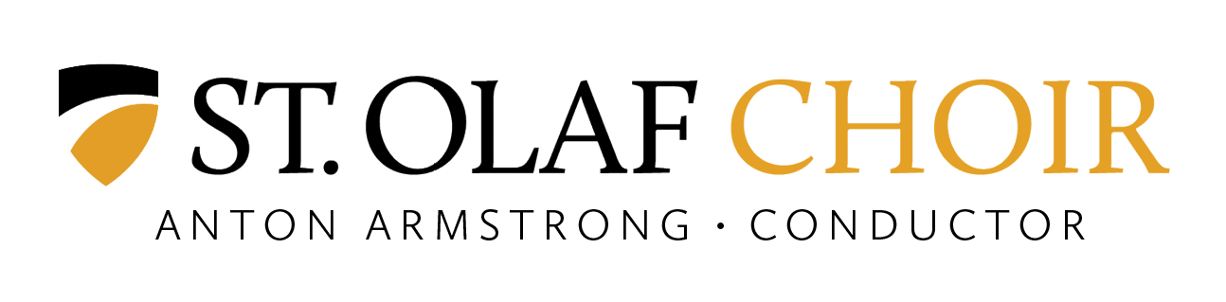
The St. Olaf Choir, with 75 mixed voices, is the premier a cappella choir in the United States. For over a century, the choir has set a standard of choral excellence and remained at the forefront of choral artistry. Conducted since 1990 by Anton Armstrong, the St. Olaf Choir continues to develop the tradition that originated with its founder, F. Melius Christiansen. For more information about the St. Olaf Choir, visit stolaf.edu/stolaf-choir.
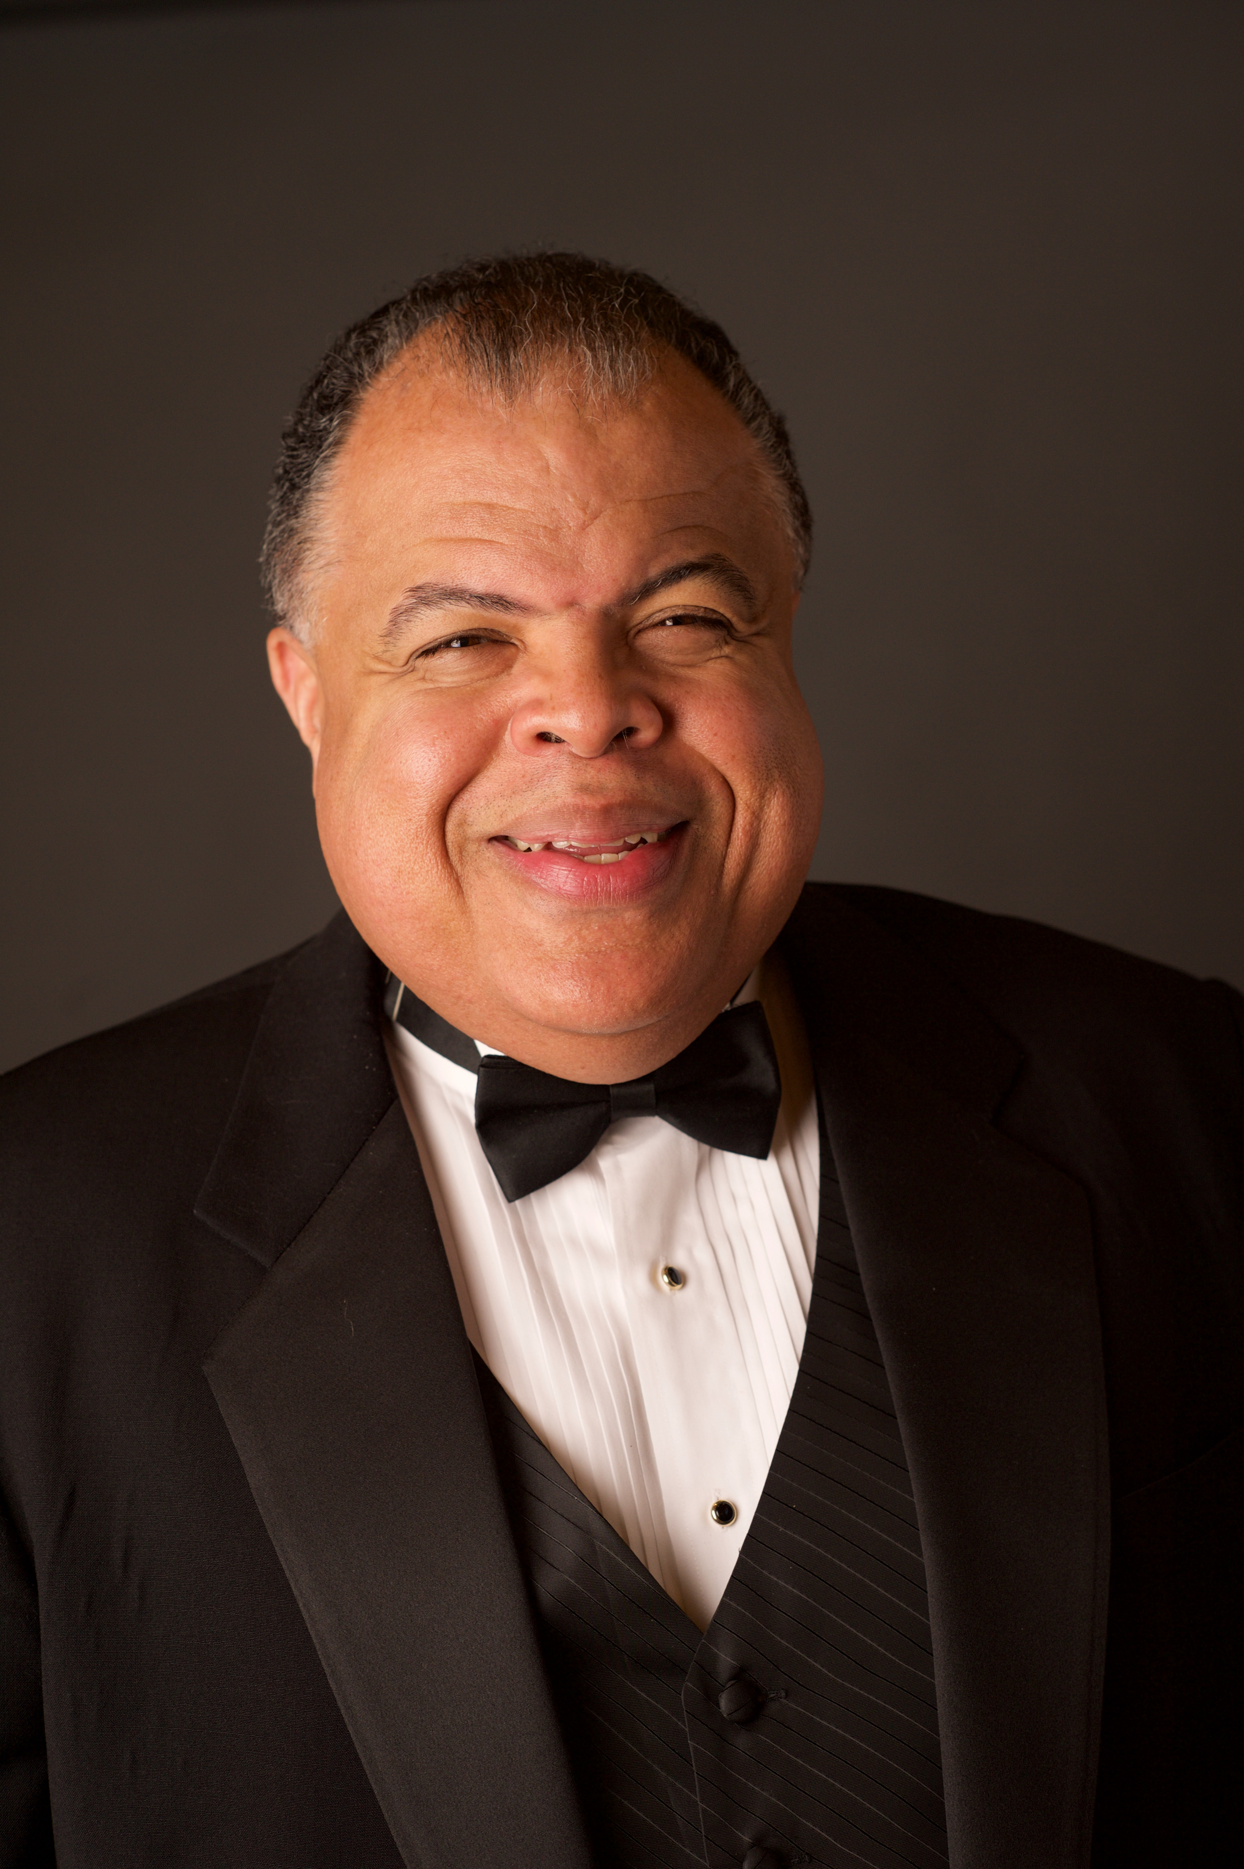
Anton Armstrong, Tosdal Professor of Music at St. Olaf College, became the fourth conductor of the St. Olaf Choir in 1990. He is a graduate of St. Olaf College and earned advanced degrees at the University of Illinois and Michigan State University. He is editor of a multicultural choral series for Earthsongs Publications and co-editor (with John Ferguson) of the revised St. Olaf Choral Series for Augsburg Fortress Publishers. In June 1998, he began his tenure as founding conductor of the Oregon Bach Festival Stangeland Family Youth Choral Academy. In January 2006, Baylor University selected Armstrong from a field of 118 distinguished nominees to receive the Robert Foster Cherry Award for Great Teaching, and he spent February-June 2007 in residency at Baylor University as a visiting professor. In October 2009, he received the Distinguished Alumni Award from Michigan State University. In June 2013, Dr. Armstrong received the Saltzman Award from the Oregon Bach Festival. The festival’s highest honor, the Saltzman Award is bestowed upon individuals who have provided exceptional levels of leadership to the organization.
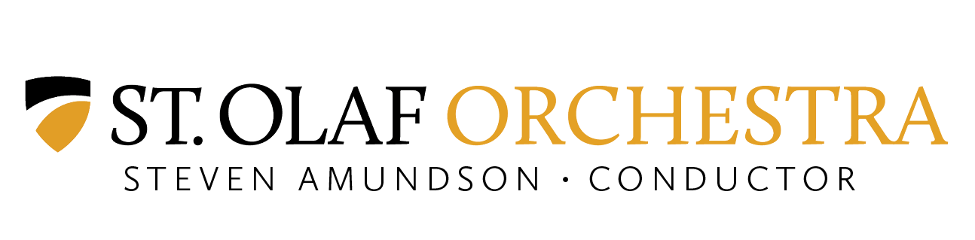
The St. Olaf Orchestra, led by conductor Steven Amundson, is recognized as “one of the best college orchestras in the nation” (Time Magazine). Winner of the 2013 American Prize for Orchestral Performance among colleges and universities, the St. Olaf Orchestra is known for its passionate music-making and professional-level performances. For more information about the St. Olaf Orchestra, visit stolaf.edu/stolaf-orch.

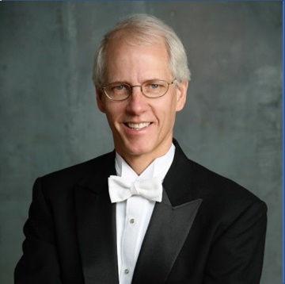
Steven Amundson joined the music faculty at St. Olaf College in the fall of 1981. Under Amundson’s direction, the St. Olaf Orchestra has become recognized as one the finest undergraduate orchestras in the United States. In addition to his duties as conductor of the St. Olaf Orchestra, he teaches courses in conducting, aural skills, and music theory. Amundson has conducted many of the United States’ All-State orchestras, and has served as a guest conductor for the Interlochen National Arts Camp and several professional orchestras, including the renowned Saint Paul Chamber Orchestra. The award-winning conductor is also an active, commissioned composer. His orchestral works have garnered nearly 1,000 performances.

ABOUT CLASSICAL MOVEMENTS:
Moving the Music, Changing the World
The premier concert tour company for the world’s great orchestras and choirs, Classical Movements creates meaningful cultural experiences through music in 145 countries. An industry leader for over a quarter-century, Classical Movements organizes more than 60 tours every year, producing some 200 concerts every season. Producer of two international choral festivals—Ihlombe! in South Africa and Serenade! in Washington, D.C.—and the Prague Summer Nights: Young Artists Music Festival, in addition, Classical Movements’ Eric Daniel Helms New Music Program has commissioned over 75 works from Grammy, Oscar and Pulitzer Prize-winning composers. Winner of Americans for the Arts’ BCA10: Best Businesses Partnering with the Arts Award, since its founding in 1992, as a truly global company, Classical Movements remains committed to facilitating cultural diplomacy across the world—promoting peace through the medium of music.

PRESS CONTACTS:

Anne Stickley, Marketing and Design Manager
+1 (703) 683-6040
anne@classicalmovements.com

Kulturoperatørene AS (Norwegian representative for Classical Movements)
Ingunn Ek, Project Leader
+47 916 07 866
ingunn@kulturoperatorene.no

