Flowers and the Love of Wisdom in Iran
A report on some philosophical adventures in the Islamic Republic of Iran, Summer 2014

Charles Taliaferro (Department of Philosophy, St. Olaf College)

When I landed at the Tehran Iman Khomeini Airport in Iran, it was with a sense of risk. After all, the airport is named after the great Ruhollah Mostavi Moosavi Khomeini (1902-1989), the Grand Ayatollah, the Supreme Leader, who led Iran to overthrow the Shah in the 1979 Iranian Revolution and who supported the Iranian students (part of the Muslim Student Followers of the Iman’s Line) who held over sixty Americans hostage for 444 days, and who referred to the American government as the Great Satan. I was travelling with Thomas Churchill, a recent graduate of St. Olaf College, where I am a professor and the current Chair of the Department of Philosophy. Thomas has the face, character, and manner of one of God’s angels, and I was relying on his heavenly credentials to see us through.

Not surprisingly, Thomas was magnificent; he was an active, engaged participant in the conference dedicated to Murtada Mutahhari that took place in the holy city of Qom. In the photos bellows, Thomas is the bearded fellow who looks somewhat like the actor Ben Affleck in the 2012 film Argo, a movie about the rescue of some of the employees from the American Embassy in Tehran who were in hiding at the Canadian Embassy.

My worries at the airport were completely groundless. We were met by a number of Iranians, including the son of Murtada Mutahhari and two journalists from the Tehran Times, who all became dear friends in the days ahead.

We were given some flowers on arrival. The practice of the attaching meanings to flowers dates back to the Persian Empire in what is now Iran and Turkey. Although I am no expert on the topic, after we spent a week with our new friends Thomas and I could have given them, when we left the Tehran Iman Khomeini Airport, a Jonquil (meaning Your affections are returned), a Carnation (You are fascinating), a Pheony (I’m shy but I like you a lot), a Lily (You’re a good friend), and a Tulip (You’re a great host!).

The first day in Iran was a matter of recovery, meeting a fellow American philosopher, Kelly James Clark, and a British-based philosopher with whom I had worked before but had never met in person, Gwen Griffith Dickson. The conference hall could seat about 500 people and at one point it seemed completely filled. Gwen, Kelly, and Thomas were all wonderfully present and engaged.

There were many moments during the conference that Thomas and I found brilliant: presentations by Ahmad Ahmadi, Mohsen Javadi, Mohammed Scidimehr, Mohammed Legenhausen. And we were hugely impressed by Mohammed Mutahhari, the son of the man to whom the conference was dedicated. His dissertation on the religious believer and the academy is among the best I have read.

The philosophy of Mutahhari that was the focus of the conference is very much a philosophy—in terms of methodology and content—that I share. Mutahhari (1920-1979) was highly educated in both Near Eastern and Western philosophy and left us a body of work that ably shows why the Western turn against theism was unwarranted (he offers replies to Hume and Kant) and offers a brilliant diagnosis of the problem of despair that one sees in many Western philosophers who are skeptical about objective values and are wholly convinced that all individual human life ends in absolute annihilation. In Mutahhari’s work on causation, being, the self, the body, wisdom, justice and mercy, human freedom and divine providence, I came to see a first-rate Muslim philosopher (or philosopher who is a Muslim) whose life came to have special significance to me in ways I had not expected.

From the outset, I felt a strange bond between myself and the son of Murtada Mutahhari. Partly this may be because his father resembled my father in stressing the importance of both the mind and heart, the intellect and the emotions. They also both had a gift for teaching abstract ideas in concrete terms. Moreover, I learned that his father saved him from drowning. I have a vague recollection of my father doing the same, albeit Dad helped me in some rough surf along the Florida coastline, whereas Muhammed’s father helped him in the Caspian Sea some 10,000 miles away. This bond (whether real or imaginary) led me to make something like the following claim at the conference:

If more fathers loved their sons the ways in which our fathers loved us—or, putting the point more generally, if more parents loved their children the way our parents loved us—then, rather than living with enmity, perhaps all of us might live with each other as true brothers and sisters.

I had planned on saying something like it (I produced the above paragraph by referring to my notes from the conference), but when I said the words, it felt like something I was led to say, and not something that came only from myself.

I also felt led to offer a tribute to Murtada Mutahhari that has been of increasing importance in my experience about understanding the practice of philosophy as the love of wisdom. The background for this tribute was a presentation by Kelly Clark.

Dr. Clark made an extensive defense of what is known as Reformed Epistemology, according to which, religious beliefs do not require discursive reasoning or rational arguments to be warranted. Clark has defended this position in books and articles, and I leave to one side his arguments here except to report that, at a crucial point in his presentation he asked (rhetorically), “Who needs arguments?” He did not reject the utility of any arguing over questions of religious belief, but he was making the case that just as many common sense beliefs (we live in a world where people think and act as they appear to, and so on) do not require arguments or reasons, religious beliefs need none. Clark also noted that professional philosophers are among the least likely to be responsive to religious experience and beliefs owing to the astounding correlation between working in academia and those who are autistic or who have Asperger’s. According to some social scientists, abstract thinkers show signs of not being able to pick up on or interpret the emotions and moods of others. They are, instead, like “calculating machines.”

In a reply I distinguished between the practice of philosophy as the love of wisdom and institutions of philosophy. It is doubtful that someone struggling with issues in religion or ethics truly loves wisdom if they think that the highest prestige and reliability should be accorded to knowledge gained through calculating machines. On matters of argument, I proposed that we need to be clear about the difference between an argument and a quarrel or the use of manipulative rhetoric. I did not cite the passage that follows at the conference, but here is Roger Scruton’s account of interpersonal exchange. It captures why it is we seek to reason with each other and develop arguments rather than, say, try to change people’s minds through manipulation:

When I am interested in someone as a person, then his own conceptions, his reasons for action and his declarations of resolve are of paramount importance to me. In seeking to change his conduct, I seek first of all to change these, and I accept that he may have reason on his side. If I am not interested in him as a person, however, if, for me, he is a mere human object who, for good or ill, lies in my path, then I shall give no special consideration to his reasons and resolves. If I seek to change his behaviour, I shall (if I am rational) take the most efficient course. For example, if a drug is more effective than the tiresome process of persuasion, I shall use a drug. Everything depends upon the available basis for prediction. To put it in the language made famous by Kant: I now treat him as a means, and not an end. For his ends, his reasons, are no longer sovereign in dictating the ways in which I act upon him. I am alienated from him as a rational agent, and do not particularly mind if he is alienated from me.
I suggested at the conference the further point that in authentic philosophical exchanges in the spirit of the love of wisdom there are only rare moments when one should use the techniques of strategy that we often find in other areas of life such as in sports, business, and warfare. In those areas, some form of deception or concealment can be essential in winning a game, contract, or battle. One tries to surprise the “enemy” and throw them off balance. In such competitions, throwing your opponent into confusion and self-doubt can be a standard practice. But in an exchange in which one truly loves wisdom, one needs to put such competitive techniques of fostering self-advantage to one side.

Photos:

Thomas Churchill ’15:
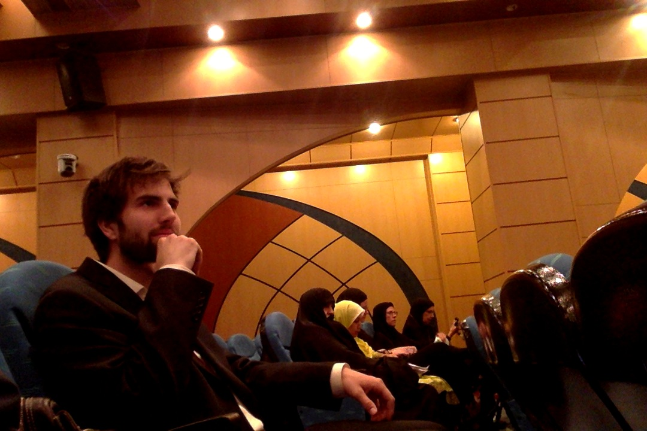
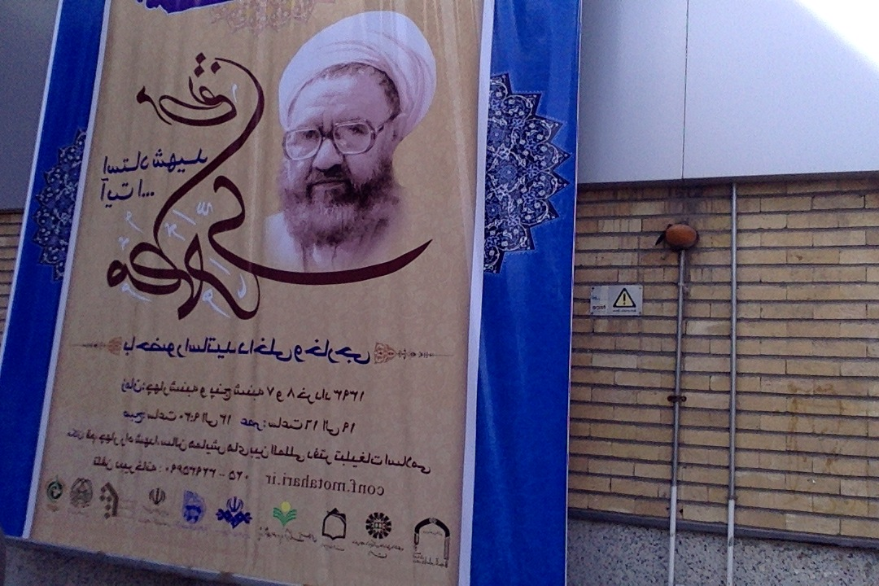
We had a police escort to and from the conference center…
…and followed the proceedings with absolute fascination and awe:
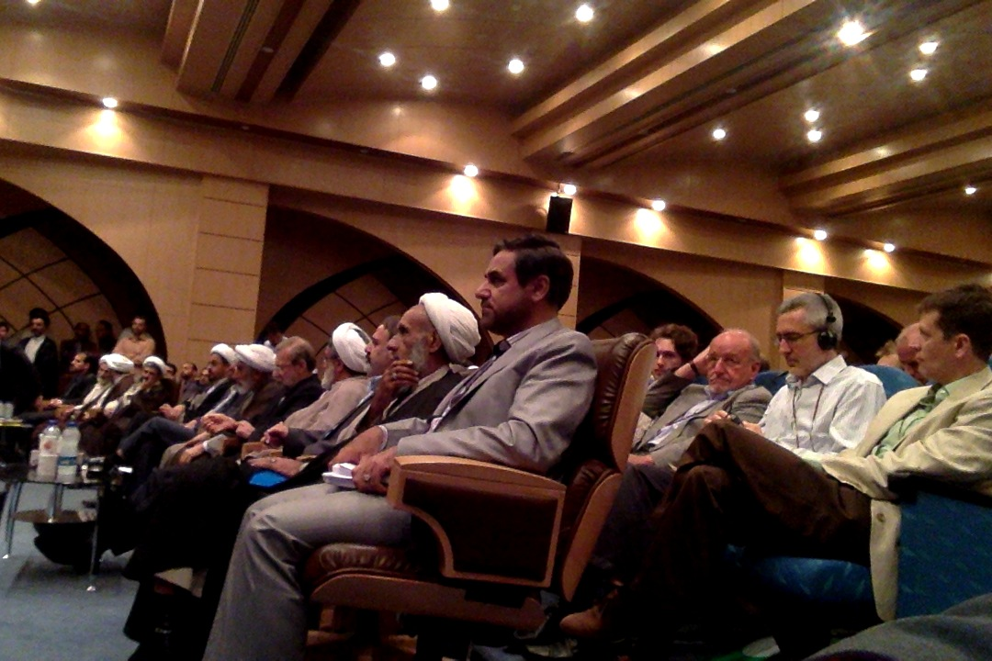
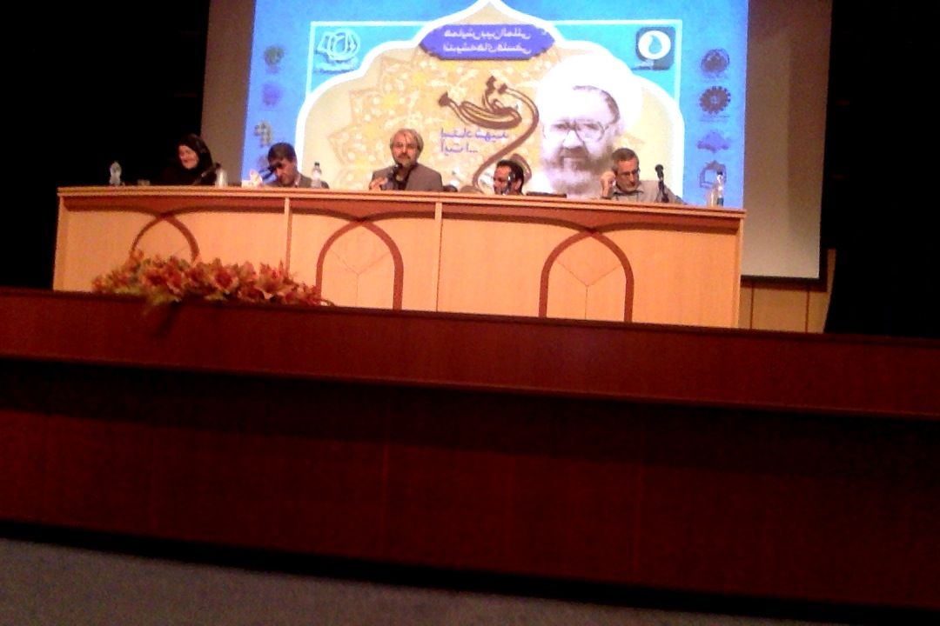
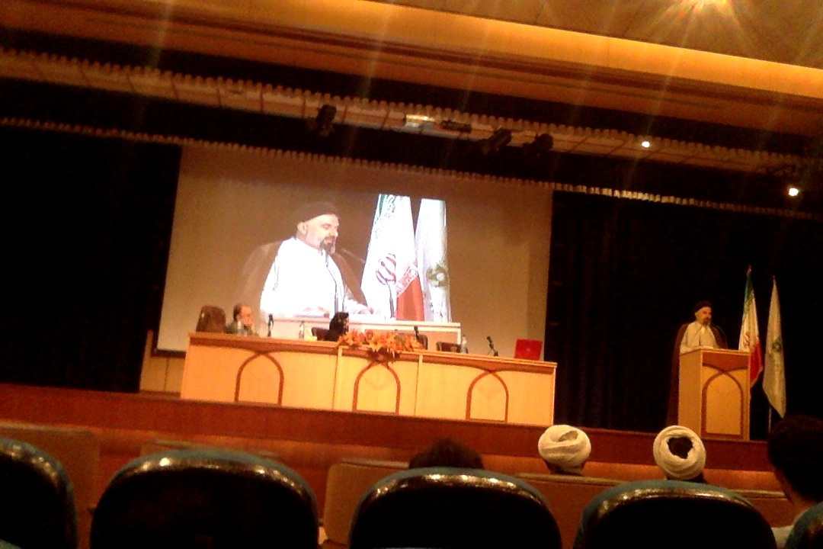

Here Thomas and I review notes moments before the talk I gave:
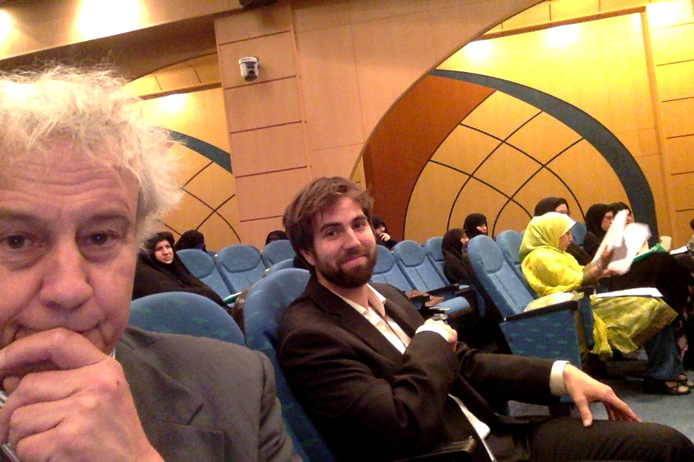
Here is Dr. Clark: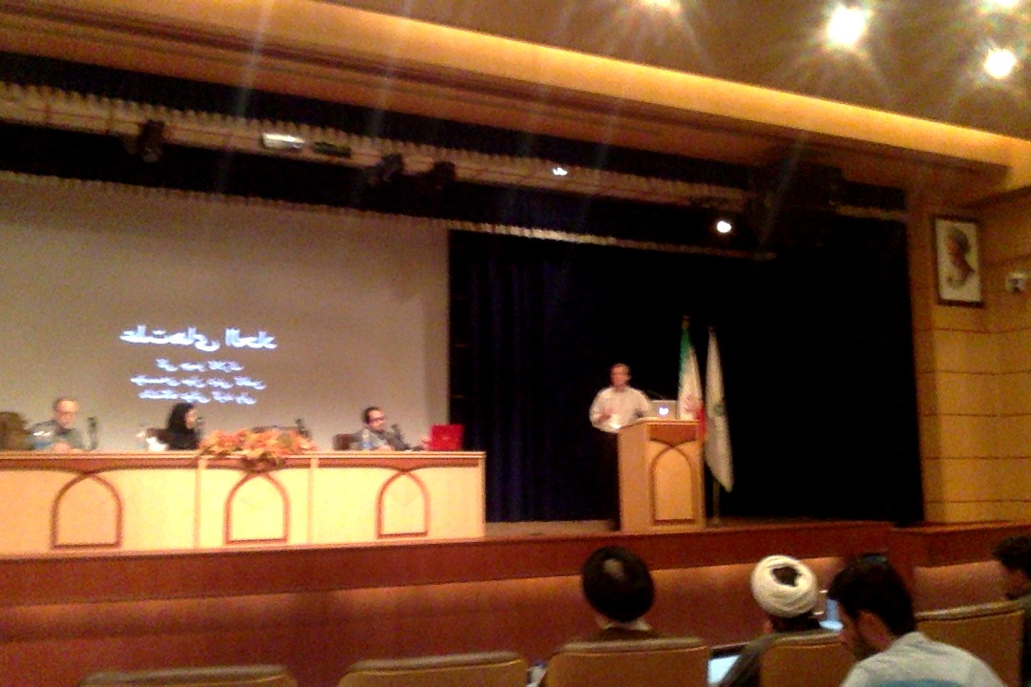

One of the great joys was to appreciate the presentations of Gwen Griffith Dickson; as the sole female presenter she did a brilliant job representing female philosophers as having an important voice:
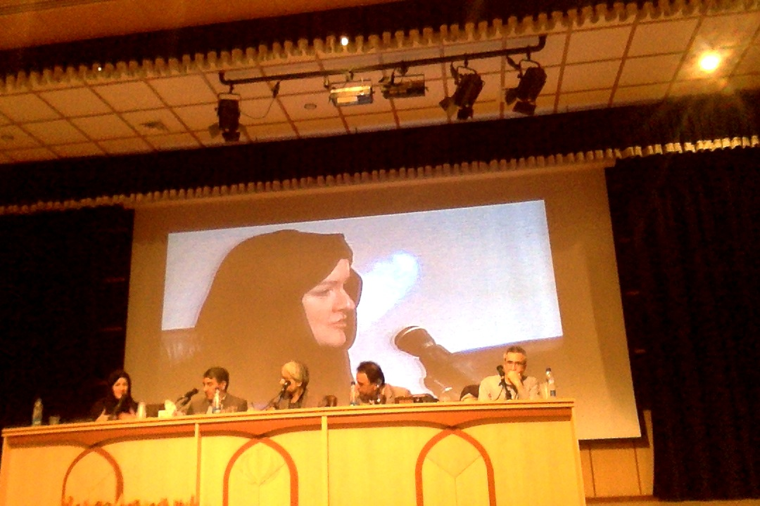
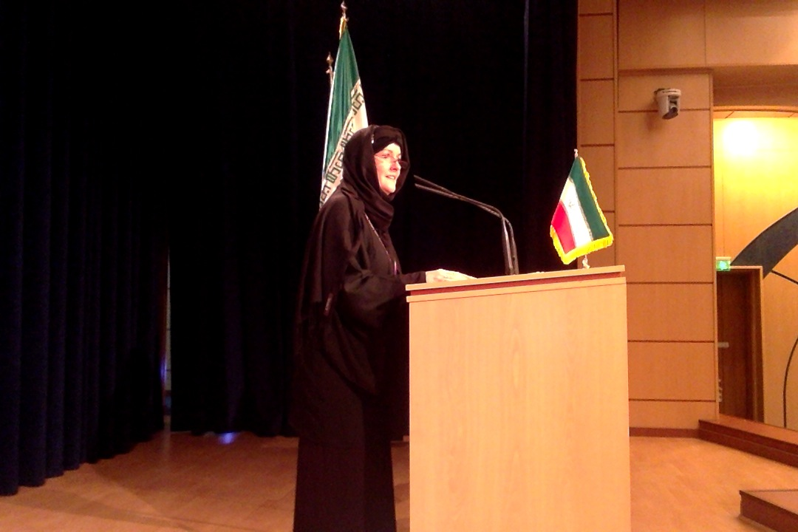

Some shots of us at dinner with our hosts:
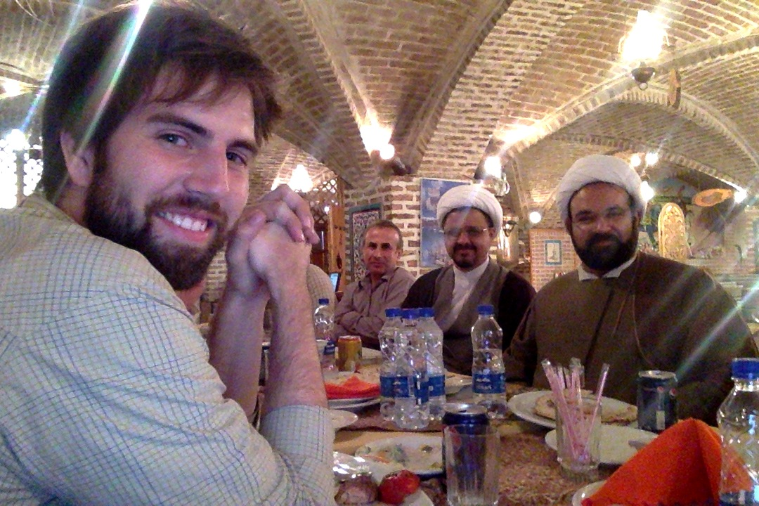
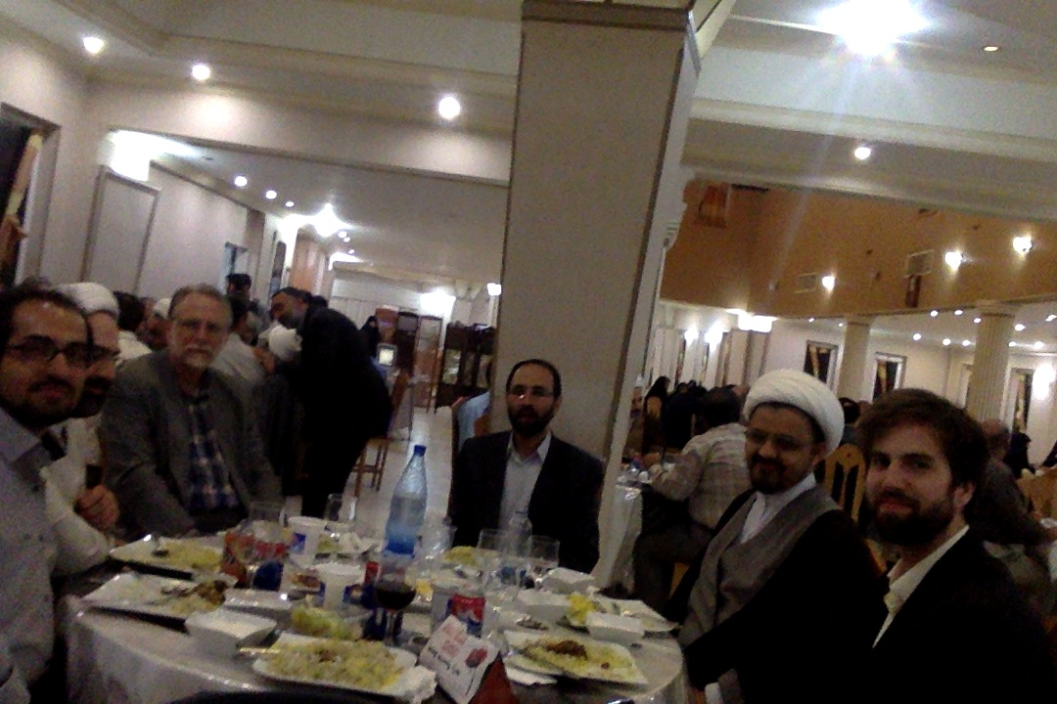

Her I am with a journalist from the Tehran Times:

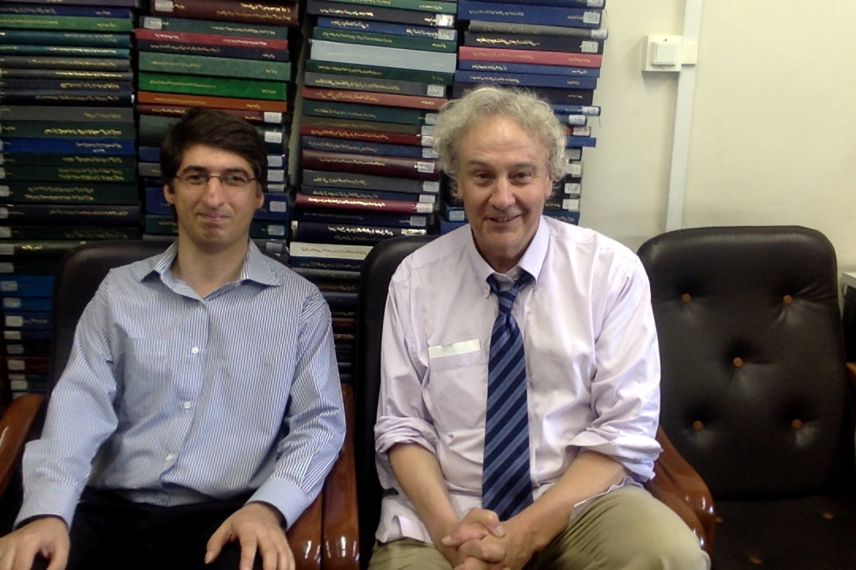

The Tehran Times ran a front-page interview with me that came out the day we left Tehran:
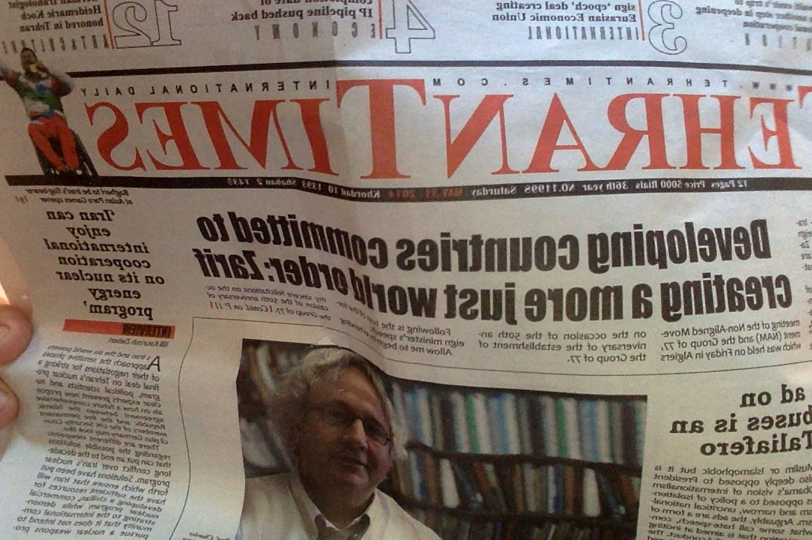

Some more, festive images:
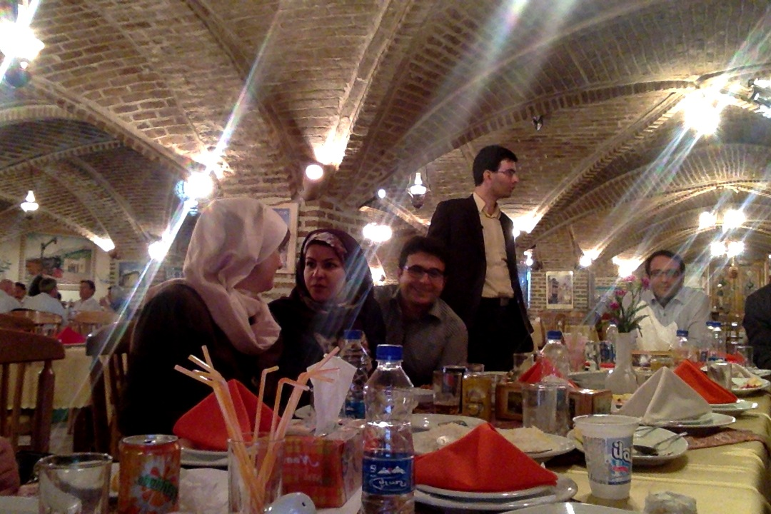
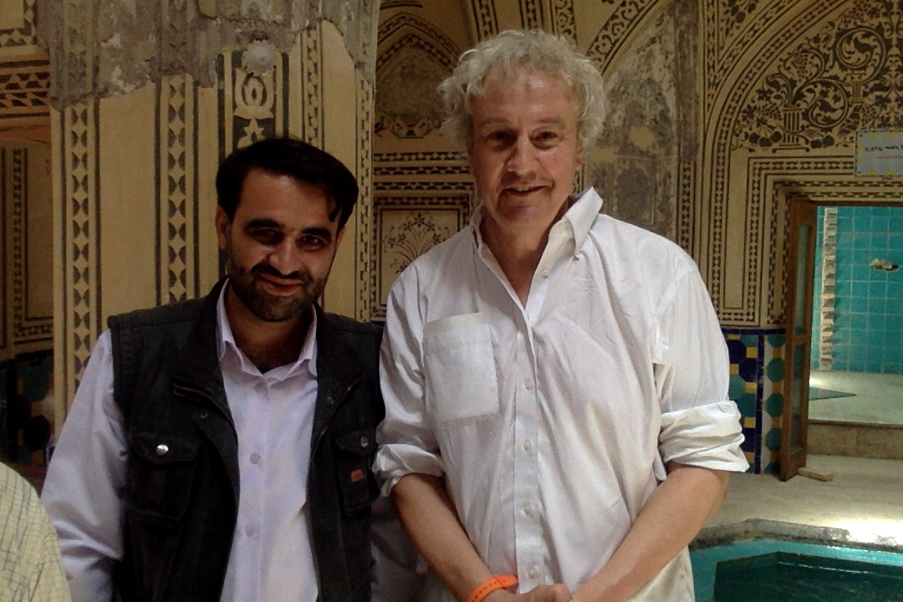
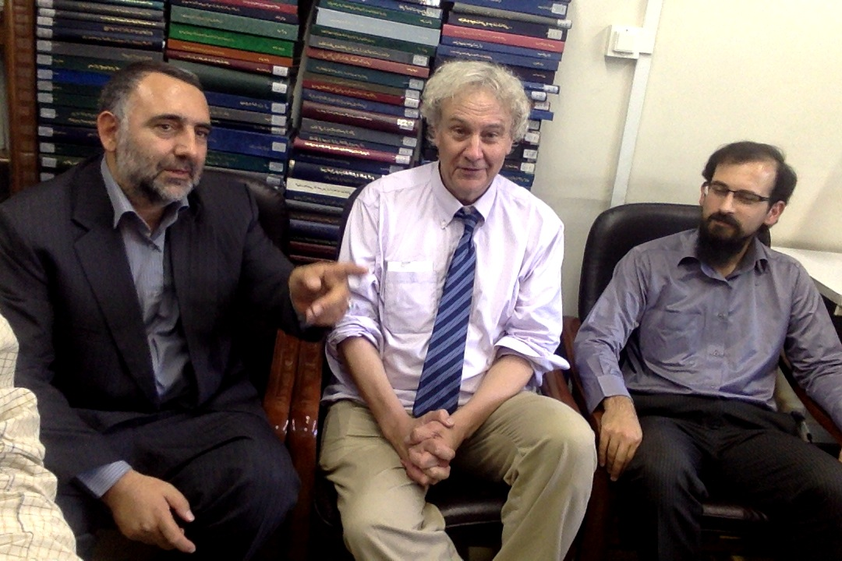

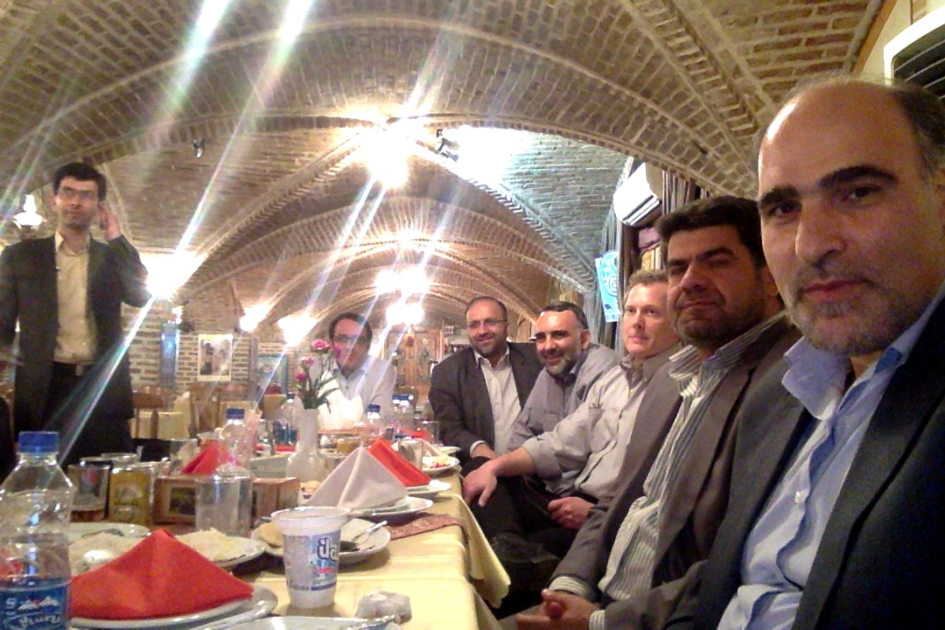
I close with an image of Thomas, who, upon receiving his BA, was worried (in a playful sort of way) that he was going to be buried in doctoral dissertation at the University of Tehran:
