Hello Philosophy Majors,
This year the Philosophy Department worked with the Piper Center in an effort to help philosophy majors find internships and start looking at careers!
Here are a few things that YOU can do through the Piper Center to get you started:
1. Handshake Handshake is a great new website St. Olaf is using to post jobs and internships relevant to your interests! It's very easy to use, and even easier to sign up. All St. Olaf students can sign in with their St. Olaf username and passwords. All you have to do is go to the link below to get started! stolaf.joinhandshake.com/
2. Go to the Piper Center
The Piper Center offers hands on help and advice on your future career needs. It's very easy (especially with Handshake) to set up appointments with Life Coaches who can help you with questions and preparations concerning internships, jobs, or your future in general. Coaches have certain fields of expertise, so if you know what you are looking for you can start immediately with someone familiar with those interests! But if you just have a minute, or are unsure where to start, you can always drop in and meet with a peer advisor to go over resumes, initial questions, getting started in the Piper Center, and which coach is best for you!
There are also drop in hours from 3-5 pm Monday through Friday in the Piper Center where you can meet with available coaches.
3. Internship Database
St. Olaf also offers an entire database displaying internships held by former or current St. Olaf students. This will give you a good idea of what people with a philosophy major have done. You can access the database here:
http://wp.stolaf.edu/pipercenter/internship-database/

(Use your St. Olaf username without @stolaf.edu, and your password)
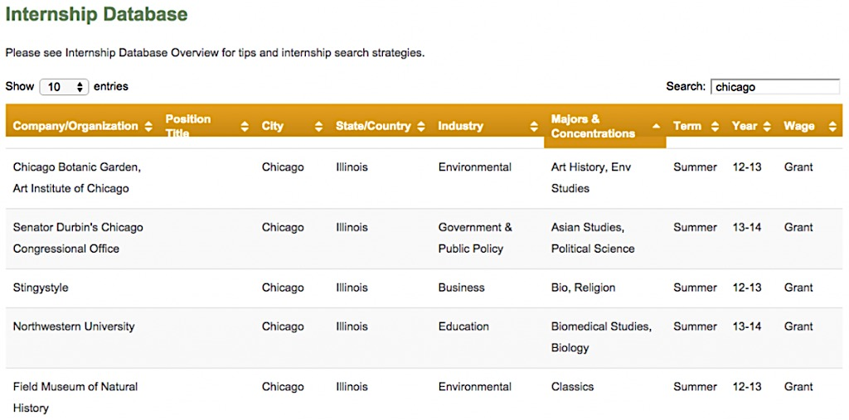
4. Explore the Piper Center Website!
There are many pathways within the Piper Center website to help you decide what you want to do or help you find a job. One specific tool within the website which can be helpful is through the ‘Majors and Careers’ tab. Click on the tab, then click ‘Explore Careers’, and finally select 'What Can I do with this Major?' If you are still uncertain what you want to do with your philosophy major, this link may have some answers.

5. Pathways
Pathways is Carleton's equivalent to St. Olaf's 'What can I do with this Major?'
https://apps.carleton.edu/pathways/

This is also an excellent tool for showing you what you can do with your philosophy major after college.
6. LinkedIn
Lastly, LinkedIn can be an invaluable resource and tool. Networking is an essential device for making connections with employers and people who can help you achieve your goals. Within LinkedIn, if you go to the St. Olaf page and select ‘Alumni’, you can see graduates of St. Olaf. Search the page for people who are doing things in fields that interest you! Emailing St. Olaf is one way to begin networking which helps you find what really interests you.

The Piper Center website also has tips on how to begin the Networking process here:

http://wp.stolaf.edu/pipercenter/networking/

Possible Career Options:
- Social Justice
  - NY Union Semester Internship
- Ethics
  - Bioethics Internship
- Law
  - Asian American Legal Defense and Education Fund (AALDEF)

Internship Possibilities
Government Departments
Environmental Agencies
Non Profit Organizations
Law/Paralegal/Criminal Justice
Faith Based Opportunities
Healthcare
Publishing

http://wp.stolaf.edu/pipercenter/elo-in-philosophy-religion/

Career Possibilities
Architecture and the Fine Arts
Business and Management
Communications and Public Relations
Education
Finance
Health and Human Services
Law
Medicine
Religion
Science and Technology
And many more!
http://wp.stolaf.edu/pipercenter/the-job-search-process/

Department of Philosophy, 2016.

PHILOSOPY
AND
YOUR FUTURE

How to use the resources at the Piper Center

