**Student Employment and Job Satisfaction**

Emma Anderson, Kaitlin Moe, and Gina Mueterthies

SOAN 371: Foundations of Social Science Research – Quantitative Methods

St. Olaf College

Fall 2021

**Executive Summary**

In the fall of 2021, the Sociology/Anthropology 371 students conducted research on job satisfaction within student employment. We sent an anonymous online survey to 2,249 students, all of whom are currently employed at St. Olaf College. We received 557 responses, a 24.8% response rate.

Prior studies have found that college student campus employment is shaped by relationships with supervisors and coworkers, work-study financial aid, and job training, and that it shapes job satisfaction, the topic of our team’s research. Our research focuses on four main questions: How frequently and in what ways do St. Olaf students experience positive aspects of their student work? How frequently do St. Olaf students experience negative aspects or stressors in their student work? How satisfied are St. Olaf students with their work-study jobs? What main factors affect students’ job satisfaction?

The most important results of our research are:

1. About three-quarters of respondents report that they generally feel satisfied with their jobs. They cited scheduling flexibility, meaningful work, positive work environments, and self-direction as strong influencing factors.
2. Students who experience more job stresses such as burnout, exhaustion, and busy work tend to have less job satisfaction than students who experience lower levels of job stresses.
3. Across all job categories on campus, students working in Food Services reported significantly lower scores on job satisfaction than those working in all other job types.
4. Students in higher class years have higher levels of job satisfaction than students in lower class years.

Based on our results, we have three recommendations for promoting higher student job satisfaction and thus lower turnover in student-worker jobs:

1. Evaluate current pay and work imbalance in busy, manual labor jobs. Higher pay and/or increased benefits would improve the satisfaction of students in these positions.
2. Allow students more flexibility when it comes to scheduling and tasks (i.e., increased ability to take work off for academic reasons). This increase in flexibility and self-direction will provide students with a much more balanced student employment experience.
3. ​​Hire non-student staff for food service positions and open up more positions in other job categories for student workers such as student services, administration, and education. This will allow more students to have satisfying employment.

**Introduction and Literature**

It is becoming increasingly necessary for 21st century college students to find a student job to help fund tuition and outside costs not covered in the institution’s financial aid package (Nuñez and Sansone 2016; McNall and Michel 2011). Data from 2003 shows that about 80% of college students worked while enrolled as full-time students (Wyland et al. 2015; and Tessema et al. 2014; McNall and Michel 2011) and that one out of every three college students view themselves as employees who study. In 2010, between 35 and 40 percent of Latino college students were working while completing their studies (Nuñez and Sansone 2016). Education and student work greatly impact young people’s futures (McNall and Michel 2011), and we must attend to the outcomes of these relationships, how students feel about their experiences, and what areas need improvement.

*Job Satisfaction*

Job satisfaction, or how students feel about their job experiences, has been the topic of many studies. Job satisfaction can be a very personal and subjective phenomenon, related to many factors including feelings of motivation, persistence, seeing room for self-improvement (Tessema et al. 2014), workplace relationships with other students and supervisors (D’Abate et al. 2009), independence, fun, pride, meaning and purpose in work, self-confidence, feeling good by helping others and being role models (Nuñez and Sansone 2016), and experiencing burnout and engagement (Alarcon and Edwards 2010). Another approach to defining job satisfaction includes the ability to be flexible with schedules in both work and school roles, having autonomy in how tasks are done or what the tasks even exist, and gaining useful skills for other roles, both present and future (Wyland et al. 2015; McNall and Michel 2011).

Job satisfaction depends partly on the interaction of different roles one inhabits in life. In the liminal years of college life for the average 18-22 year old, the most common roles are student and employee. According to role theory, managing these multiple roles can be challenging, especially when demands are imbalanced, leading to interrole conflict (McNall and Michel 2011). Interrole conflict is the degree to which one role hinders or interferes with a person’s capacity to meet the responsibilities and demands of their other roles (Wyland et al. 2015; McNall and Michel 2011). However, inhabiting multiple roles can be highly beneficial under the right circumstances (Wyland et al. 2015). Role facilitation or enrichment is defined as the extent to which one role improves the quality or experiences of another (Wyland et al 2015; McNall and Michel 2011).

Conservation of Resources (COR), or the availability of resources, is affected by Role Theory and the demands of each role within the relationship being studied. Limited resources that must be spread thin between multiple roles to meet multiple demands increases opportunities for, and the strength of, interrole conflict. When more resources are directed toward one role while ignoring another role, the imbalance and conflict increases (McNall and Michel 2011). Frequent experiences of interrole conflict increase feelings of burnout and create a cycle of conflicts moving forward (Alacron and Edwards 2010). For example, a pressing demand in a person’s work role increases pressure on them as an employee to devote more time to work, removing them from their role as a student and leading to conflict through neglect of school assignments or extracurricular responsibilities (Wyland et al. 2015).

If it is the case that resources are not finite or are at least sufficient, then inhabiting multiple roles can be highly beneficial for a college student-employee relationship. With sufficient resources, a person is able to find a healthy balance between multiple roles that leads to the acquisition and growth of skills, networking and social capital, increased commitment to each role (McNall and Michel 2011), and more frequent feelings of engagement with each role (Alacron and Edwards 2010).

*Measurement of Job Satisfaction*

Prior research on job satisfaction has used several different methods of measurement. D’abate et al. (2009) utilized three items from Hackman and Oldham’s 1975 job diagnostic survey, which used items such as “Generally speaking, I am very satisfied with this job” with response options on a frequency scale ranging from Never to All the time (2009:195).

Similarly, McNall and Michel (2011) measured job satisfaction using a three-item scale from Spector et al. (2007) which included items such as, “After all, I am satisfied with my job” and “In general, I like my job.” Their response options used a 5-point Likert scale ranging from Strongly Disagree to Strongly Agree (2011:402).

Alarcon and Edwards (2010) used the Michigan Organizational Assessment Questionnaire which included three items such as, “All in all, I am satisfied with my job,” with response options on a seven-point Likert scale ranging from Strongly Disagree to Strongly Agree (2010:e296).

*Dimensions and Contributing Factors of Job Satisfaction*

Job satisfaction contributes to work-related outcomes such as skills gained and co-worker relationships. Skills that can be gained through student employment range from organizational skills to interpersonal skills, and any skill that can positively impact a student's experience may contribute to their job satisfaction. D’Abate (2009) found that students who display skills such as organization and time-management are more likely to be offered full-time positions in the future.

Researchers have evaluated a wide variety of potential positive and negative factors contributing to job satisfaction. Alarcon and Edwards (2010) found that engagement, dedication, and absorption were all significant predictors of job satisfaction. Engagement, defined as a generally positive feeling or affective relationship regarding work (2010:e294), is informed by three main contributing factors: vigor, the presence of ample energy and resilience at work; dedication, a sense of enthusiasm, commitment, and diligence regarding working; and absorption, which is characterized by effortless concentration, similar to the idea of a flow state (2010:e295).

Creed (2019) emphasized co-worker relationships and their contribution to meaningful work, stating that relationships have a strong connection to work attitude and that positive co-worker relationships contribute to job satisfaction.

Another significant contributor to job satisfaction is the work environment and the students' connectedness to their place of work. Job satisfaction stems not just from the work itself but also from the work environment (D’Abate 2009). The environment of a workplace can refer to the employees, supervisor, and even office space in which the work takes place. D’Abate (2009) found that these environmental factors can account for different satisfaction experiences.

Further evidence that a student's job satisfaction is affected by personal connections as well as skills gained also comes from D’Abate (2009). After evaluating the effect of a job’s permanence on satisfaction, they concluded that connections and skills gained have a more significant impact on students’ job satisfaction than job permanence. A student may be very satisfied with their employment but in some cases, that job is temporary and may not be available next year. This can lead to students feeling discouraged or unmotivated to apply for other available jobs on campuses, but it does not affect satisfaction with their existing job.

Positive impacts from a student’s work role on their academic life also contribute to job satisfaction. For example, Wyland et al. evaluated work-school facilitation (WSF) and school-work facilitation (SWF), which are respectively defined as one’s work role improving the quality of their school role and one’s school role improving the quality of their work role (2016:188). WSF was significantly positively associated with increased job satisfaction, but SWF was not significantly related (2016:199).

Similarly, work experiences and skills that enhance academic performance also contribute to job satisfaction. McNall and Michel (2011) explored the potential relationship between work-school enrichment (WSE) and job satisfaction. WSE refers to the extent to which work experiences and skills gained increase the quality of one’s school role experience (2011:398). This would occur, for example, if skills learned through one’s job helped them with a school-related assignment or obligation. This study found that WSE is a significant predictor of job satisfaction.

Level of pay also contributes to job satisfaction. There is a positive relationship between a student's job satisfaction and the level of pay they receive. Nuñez (2016) explained that although outcomes such as gained skills are important, sometimes a student's income is what is prioritized.

Several studies have also examined potential inhibitors of job satisfaction. Wyland et al. (2015) considered the potential impacts of work-school conflict (WSC) and school-work conflict (SWC) on job satisfaction. They defined conflict as incompatible demands from two or more areas of one’s life (2015:187). WSC occurs when work-related demands conflict with school-related demands and SWC occurs when school-related demands conflict with work-related demands (2015:188). For example, a student who cannot put as much effort into their work-related tasks because they have too many school-related tasks to complete is experiencing SWC. However, WSC and SWC were not significant predictors of any job-related outcomes, including satisfaction (2015:197). McNall and Michel (2011) also examined WSC and found similar results -- there was no significant relationship between WSC and job satisfaction.

Conversely, burnout is a significant predictor of turnover intentions (defined as one’s desire to quit their job or find a different one), which are directly related to job satisfaction. Alarcon and Edwards (2010) characterized burnout by exhaustion, low motivation, and pessimism regarding one’s job as well as a lack of resources and a competing abundance of demand (2010:e295). They drew this definition from conservation of resources theory (Hobfoll,1989; Hobfoll et al. 1990). After evaluating the relationship between burnout and turnover intentions, burnout was identified as a significant predictor of turnover intentions (2010:e295).

*The Role of Student Demographics*

Many of the college students taking on employment for school-related financial reasons are doing so under conditions of increasing diversity on campuses across the country. How students interact with their college and work positions is greatly impacted by their demographics such as race, socioeconomic status, gender, whether or not they are a first generation-student (Nuñez and Sansone 2016), and class year (D’Abate et al. 2009). Understanding these relationships gives us another perspective on job satisfaction, as situations of discrimination and empowerment vary depending on the position held and the institution the student is enrolled in. It is important to recognize that higher education can reproduce social inequality, but it also provides opportunities for social mobility and increasing equality (Nuñez and Sansone 2016).

*Addressing Gaps in the Research*

Prior studies reveal gaps in the literature about job satisfaction among college student workers, and our research addresses some of these gaps. We did this by exploring how work-school enrichment affects job satisfaction at St. Olaf College. Specifically, we examined how students are able to balance school and work and at what level they experience burnout. We also examined the role that job pay plays in engaging a student in their employment and in affecting their job satisfaction, and whether a pay increase would increase job satisfaction. We also explored how job characteristics such as level of autonomy, meaningfulness, and task variety affect job satisfaction. Finally, we evaluated how connected students feel to their work and the different ways they feel that they make a meaningful impact on campus.

Based on our review of literature, our research focuses on four main questions:

1. How frequently and in what ways do St. Olaf students experience positive aspects of their student work?
2. How frequently do St. Olaf students experience negative aspects or stressors in their student work?
3. How satisfied are St. Olaf students with their work-study jobs?
4. What main factors affect students’ job satisfaction?

**Methods**

We conducted research on college student job satisfaction for our Sociology/Anthropology Quantitative Research Methods course in the fall of 2021. Our research is part of a larger study of various aspects of student employment. We gathered data through an electronic survey administered to students on a work-study email alias at a small liberal arts college in the American Midwest. Respondents were anonymous and we incentivized them to complete the survey by holding drawings for several gift cards upon survey completion. The survey included questions from eight research teams on their specific topics, providing access to a large set of data.

*Variables*

Our study’s dependent variable was job satisfaction. To measure it, our survey asked respondents to rate their level of satisfaction with their job directly: “Overall, I feel satisfied with my job.” Moreover, respondents rated their agreement with the statements “I would rather work a different job,” and “If I could, I would quit my job,” as additional measures of satisfaction. Response options were on a 5-point scale from “Strongly Agree” to “Strongly Disagre” and included a “Neutral” option.

The independent variables of our research focused on positive aspects of work (job positives) such as engagement and excitement, as well as negative aspects or stressors such as busywork. We also evaluated job satisfaction based on various demographics. We measured these variables through each participant’s survey responses and created a rating system based on two different five-point Likert scales (agreement and frequency). The scales range from “Strongly Agree” to “Strongly Disagree” including a “Neutral” option and “Always or Almost Always” to “Never or Almost Never”. We also calculated three indexes from these matrices: a Job Positives index which included seven survey items related to positive aspects of work and potential satisfaction facilitators, a Job Stresses index which included three survey items related to stressors or potential inhibitors of satisfaction, and a Job Satisfaction index which included eight items of potential job satisfaction-facilitating measures not included in the positives index.

*Validity and Reliability*

We achieved face validity (a logical assessment of the degree to which a study achieves its stated goals) in the study by using a survey to gather data on the three domains of our research questions: job positives, job stresses, and job satisfaction. Additionally, our team facilitated a focus group which helped establish face validity by confirming that the variables and definitions used in the survey would be easily understood by the general student body and were comprehensive in the content they cover.

We ensured the study’s content validity (the extent to which measures address all facets of a concept) by measuring the full scope of our working definition of job satisfaction and each of its dimensions (such as exhaustion, engagement, self-direction, etc.) through our survey questions. For example, participants rated how often they experience exhaustion both before and after work in addition to a question specifically about burnout in order to assess the full scope of students’ experiences with burnout. Additionally, participants assessed their level of engagement with their jobs by rating their agreement with statements like, “I feel valued for my contributions at work,” and “I have the opportunity for self-direction at work” in addition to an item in which participants directly rated the frequency of their engagement at work. In the survey, respondents also rated their frequency of excitement regarding their work in order to assess the variable of excitement. These variables all contribute to the study’s variable of interest, job satisfaction.

Reliability refers to dependability and consistency. In order to achieve this in our research, we used several strategies. First, our survey included thorough conceptual definitions of terms like engagement and burnout (preceding relevant survey items) to ensure that participants understood those concepts and responded to relevant items with the same definitions in mind. Additionally, we ensured precision of responses by providing two separate five-point Likert scales for relevant survey items. The focus group we conducted before constructing the survey also enhanced the study’s reliability by ensuring that the survey’s concepts were easily understood and relevant to the participants. Additionally, we compiled several indexes to get a more comprehensive understanding of various subsections of the data such as job positives and job stresses. Finally, many of the study’s independent variables are established measures (such as engagement and burnout) that have been used in prior studies on the topic, demonstrating their relevance to the concept of job satisfaction. We adopted Alarcon and Edwards’ (2010) definitions of engagement and burnout, but we developed our own measures of these variables.

*Sampling Procedure and Sample*

Our target population for the survey was students employed on campus. We held a focus group which helped us gather the best insight and knowledge surrounding student employment in order to create our survey questions. We solicited our survey respondents by sending an email to the entire population of more than 2,000 students(2,249) currently employed on campus using an alias composed of all students who work on campus, including all class years. Of these 2,249 students, we gathered responses from 557 with a response rate of 24.8%. This response rate was high enough to generalize the statistically significant results in our analysis to the entire population of student workers at St. Olaf College, as it reached Neuman’s “rule of thumb” for statistical generalizability (between ten and 30 percent response rate for a population of our size) (Neuman 2012).

Of these 557 respondents, about 91%-98% answered questions pertaining to demographics. Both gender and race are coded two ways, one being an aggregated, binary coding only for analysis. This is problematic but it was the only way to conduct valid bivariate analysis for some of our data. Among the respondents who answered the demographic questions on the survey, 69.8% identified as female (352), 23% as male (116), and 7.1% as non-binary (36). In terms of race and ethnicity (non-binarized), respondents were 11.0% Asian, 3.3% Black, 8.2% Latinx, 5.8% Multiracial, and 72.1% White. International students make up about 10.2% of the student body, and our sample was 11.4% international (59) and 88.6% domestic (459). More than 50% of respondents have a parent who has a graduate, medical, or professional degree and the sample is 19.8% first generation and 80.2% continuing generation.

A variety of majors and academic disciplines were represented in the sample. The class distribution of our sample was 17.7% first years, 25.4% sophomore, 30.3% junior, 26.6% senior.

*Ethics*

While designing this survey and completing our research, our team took into consideration a number of ethical issues for the safety and well-being of the survey respondents. We sent students in the target population for our research an email with a consent statement that detailed the topic of our survey, statied that our intent with the research was to help improve student employment at St. Olaf, confirmed that responses would be kept anonymous, promised further information on the results of our research, and provided contact information for Professor Ryan Sheppard in case a student had any questions or concerns.

Recipients of the email were not required to complete the survey and were at liberty to skip any question in the survey if they did not wish to respond, although we encouraged 100% completion. Questions regarding the demographics of this population were included and did not influence which students received the email and survey.

As mentioned, each student’s responses to our survey have been kept anonymous throughout the project so that researchers are unable to distinguish which responses come from which individuals. The anonymous nature of our survey protected our respondents who shared sensitive answers about their workplace environments. Randomly assigned numbers were used to draw winners for the recipients of gift cards, but the incentives were not of a high enough value to act as a coercive factor in completing the survey. Beyond this, no names were used or referenced in connection with having participated.

**Research Results and Discussion**

***Univariate Analysis***

***Research Question 1*: How frequently and in what ways do St. Olaf students experience positive aspects (job positives) of their student work?**

We asked respondents a variety of questions in order to assess the frequency with which they experience positive aspects of work at their focus jobs (the survey guided students who had more than one work-study job to select one of those jobs to focus on for the survey), as shown in Table 1 below. Nearly three-quarters of respondents reported feeling engaged at work at least most of the time (72.2%, or 32.4 + 39.8), and slightly over half reported feeling excited to go to work at least most of the time (51.5%, or 18.2 + 33.3). Additionally, 86.3% (59.5 + 26.8) of respondents reported feeling that their contributions at work are valued at least most of the time and 81.2% (60.8% + 20.4%) reported having frequent opportunities for self-direction at work. However, a notable portion of respondents reported that positive aspects of their work were less frequent. For example, 48.5% (28.8 + 16.1 + 3.5) reported feeling excited to go to work only sometimes or less often and 23.1% (13.9 + 6.1 + 3.1) reported being allowed to make decisions about tasks only sometimes or less often. The data show a wide range of student experiences; while a large portion of respondents reported frequent positive aspects of their work, a minority reported that positive aspects of student work occurred less frequently or not at all.

**Table 1: Frequency of Job Positives**

|  |  |  |  |  |  |
| --- | --- | --- | --- | --- | --- |
| **Job Positives Matrix Item** | **Always or almost always** | **Most of the time** | **Sometimes** | **Seldom** | **Never or almost never** |
| I feel “engaged” at work (positive and fulfilled). | 32.4% | 39.8% | 4.9% | 4.9% | 2.9% |
| I feel excited to go to work. | 18.2% | 33.3% | 28.8% | 16.1% | 3.5% |
| I feel valued for my contributions at work. | 59.5% | 26.8% | 9.8% | 3.3% | 0.6% |
| I have the opportunity for self-direction at work. | 60.8% | 20.4% | 11.6% | 5.1% | 2.2% |
| My job allows me to work on my own with little immediate supervision. | 68.1% | 18.8% | 9.6% | 2.3% | 1.2% |
| My job allows me to make decisions about tasks (such as the order in which I will do them). | 56.1% | 20.9% | 13.9% | 6.1% | 3.1% |
| My job allows me to do homework while on the job. | 24.3% | 10.4% | 17.1% | 12.5% | 35.7% |

*For frequencies for each cell, see Table 16 in Appendix A.

Respondents also described their work experiences in an open response question. They mentioned a wide variety of job positives (our terms for positive aspects of students’ work-study jobs) in these responses, such as skill acquisition/improvement (mentioned 73 times), working in a positive (fun, comfortable, safe, etc.) environment (mentioned 61 times), and flexibility (mentioned 56 times). One respondent represented all three of these factors in their response to why they would recommend their job to another student: *“Flexible supervisor, practical skills, fun environment.”*

Another job positive addressed in the survey’s free response section as well as in the Job Positives matrix (Table 1) was the ability to do homework at work. This was mentioned 65 times in the free response section. The close-ended survey question revealed that 34.7% (24.3 + 10.4) of respondents can do homework at least most of the time while at work, while 35.7% almost never or never have the opportunity. Among the 65 free response mentions of doing homework on the job, 55 were positive and the other 10 expressed the desire to be able to do homework on the job. One respondent illustrated this theme by saying, *“It's so easy, you just do homework [for] most of it. Why wouldn't you want that?***”** The presence of this factor in the open-ended survey questions as well as the wide range of responses to the relevant close-ended survey question underscores that being able to do homework on the job is a notable positive factor in many students’ work experience.

We calculated an Index of Job Positives by summing the responses to each item in Table 1. The distribution of the frequency of scores is illustrated below in Figure 1. The index is scored from 0-30, but respondents’ scores only fell between 7 and 27, with a median (middle) score of 18. The mean (average) score was 17.79, indicating that respondents tend to experience positive aspects of their job more often than not. Additionally, the most common score for this index was nineteen. However, 22.6% of respondents had a score of 15 or below, indicating that while the majority experience overall frequent positive aspects of their jobs, there is a minority of respondents who experience positive aspects of their work less often.

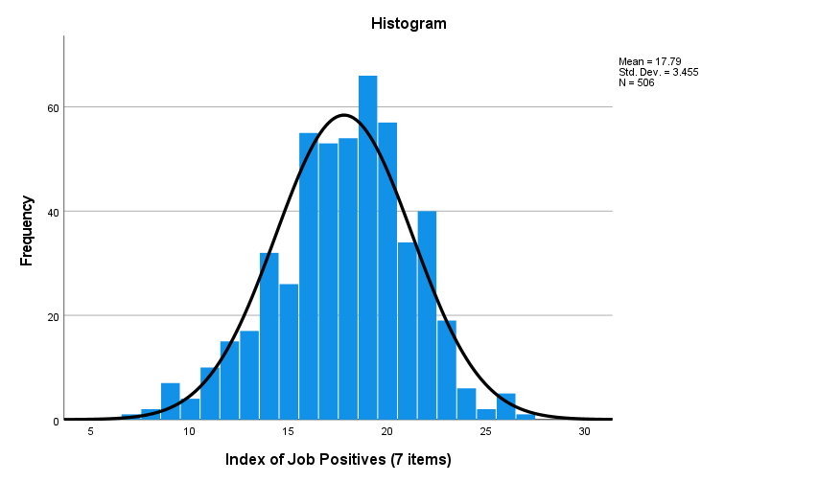

Figure 1: Histogram of Job Positives Index

***Research Question 2*: How frequently do St. Olaf students experience negative aspects or stressors in their student work?**

We asked students a variety of questions about job stresses in relation to their employment on campus, such as about experiencing exhaustion before and after work. The data describe job stresses and how frequently students experience stressors specifically, burnout, exhaustion, and busy work. Students’ responses to job stress items are shown in Table 1 below. Over 80% (83.5%, or 31.1+31.4+23.0) of students experience burnout at their job only sometimes or less. Almost 65% (or 35.5+28.1) of students reported sometimes feeling exhausted after work. More than half (56.2%, or 23.3+32.9) experience having to do busy work while at their job. Most respondents have experienced burnout and/or exhaustion at work, after work, or both.

**Table 2: Frequency of Job Stresses**

|  |  |  |  |  |  |
| --- | --- | --- | --- | --- | --- |
| **Job Stresses Item** | **Always or almost always** | **Most of the time** | **Sometimes** | **Seldom** | **Never or almost never** |
| I feel “engaged” at work (positive and fulfilled) | 32.4% | 39.8% | 4.9% | 4.9% | 2.9% |
| **I experience “burnout” at my job** | **5.1%** | **9.4%** | **31.1%** | **31.4%** | **23.0%** |
| I feel excited to go to work | 18.2% | 33.3% | 28.8% | 16.1% | 3.5% |
| I feel exhausted before I begin my shift | 5.3% | 11.0% | 37.5% | 29.6% | 16.7% |
| **I feel exhausted when I leave work** | **6.8%** | **12.5%** | **35.5%** | **28.1%** | **17%** |
| My job requires a lot of physical labor | 6.5% | 6.7% | 15.9% | 19.1% | 51.9% |
| My job requires a lot of mental labor | 9.8% | 22.4% | 28.8% | 24.3% | 14.7% |
| **I have to do “busy work” at my job** | **5.9%** | **6.8%** | **23.3%** | **6.8%** | **32.9%** |

*For frequencies for each cell, see Table 17 in Appendix A.

We created an index of job stresses from three of the items in Table 2: experiencing burnout at work, feeling exhausted after work, and having to do busy work on the job. We chose these three items because they are all negative effects or aspects of students’ employment. Busy work is defined as doing tasks that seem pointless, which can be difficult for students when they feel like their time could be better spent on something else.

The distribution of the frequencies of index scores are shown below in Figure 2. The index scores range from 0 to 12. A low number means lower experience of job stressors. The mean (average) score for the index was 4.27. as the histogram shows, nealy a;; students experience at least some sort of job stressor at some point while at work. Students who experience copious amounts of busy work tend to experience job stressors such as exhaustion and burnout. Students’ comments shed light on these stressors:

*“Since I can never do homework and am always exhausted afterwards, I wouldn't recommend it to another student.”*

*“Very strenuous for little pay. You can’t do homework, we’re understaffed and busy all of the time, with usually one student worker and a cashier."*

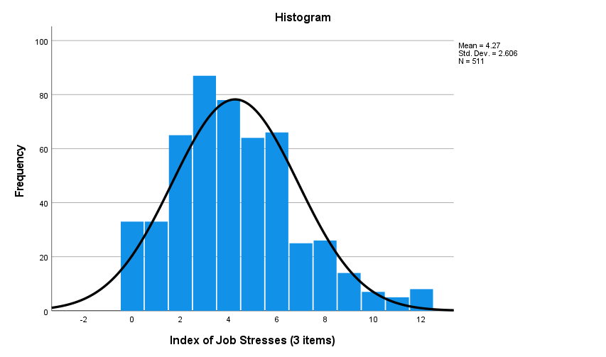

Figure 2: Job Stresses Index

***Research Question #3*: How satisfied are St. Olaf students with their student jobs?**

We asked respondents to rate their level of agreement with statements related to their satisfaction with their campus job. The statements addressed factors such as the flexibility of scheduling hours and days, how meaningful respondents consider their work to be, and whether they would recommend their job to peers, shown in Table 3 below. About three-quarters or more of the respondents agreed (strongly or somewhat) that they generally feel satisfied with their job (88.3%, or 64.5 + 23.8), have flexibility in scheduling their work hours (75%, or 49.9 +25.1) and work days (73.9%, or 53.2 + 28.4), feel their job enhances their St. Olaf experience (80.3%), that their work is meaningful (77%), and that they would recommend their job to another student (85.5%). As one student commented,

*“I would recommend it to a person who likes to interact with the community socially because it is really fulfilling.”*

At the same time, a small percentage of respondents reported that they would rather work at a different job (14.6% strongly or somewhat agreed) or that they would quit their current job if they could (9.0%).

**Table 3: Job Satisfaction**

|  |  |  |  |  |  |
| --- | --- | --- | --- | --- | --- |
| **Job Satisfaction Item** | **Strongly agree** | **Somewhat agree** | **Neutral** | **Somewhat disagree** | **Strongly disagree** |
| Overall, I feel satisfied with my job. | 64.5% | 23.8% | 6.6% | 3.3% | 1.8% |
| My job is flexible in terms of the number of hours I work. | 49.9% | 25.1% | 10.3% | 10.7% | 3.9% |
| My job is flexible in terms of which days and times I work (separate from the number of hours). | 53.2% | 20.7% | 9.4% | 9.4% | 7.4% |
| My job enhances my experience as a St. Olaf student. | 51.9% | 28.4% | 12.9% | 4.7% | 2.2% |
| My work is meaningful to me. | 53.0% | 24.0% | 13.2% | 6.9% | 2.9% |
| I would rather work at a different job. | 6.2% | 8.4% | 14.0% | 21.4% | 49.9% |
| If I could, I would quit my job. | 3.9% | 5.1% | 8.1% | 15.2% | 67.7% |
| I would recommend my job to another student. | 53.7% | 31.8% | 8.8% | 4.5% | 1.2% |

*For frequencies for each cell, see Table 18 in Appendix A

The data indicate that respondents are generally satisfied with their work situations on campus, and tend to value the work they do and to feel valued in their work. However, these factors vary across job categories and in relation to other demographic factors, as will be discussed later.

We calculated a Job Satisfaction Index by combining the scores for all of the items from Table 3. (We reverse-coded the negative items,) Figure 3 illustrates the distribution of the frequency of the index scores, with possible scores ranging from 0 to 32. The median (middle) score was 27 and the mode (most frequent) score was 32. The mean (average) score was 25.61, indicating that respondents tend to be satisfied with their job on campus.

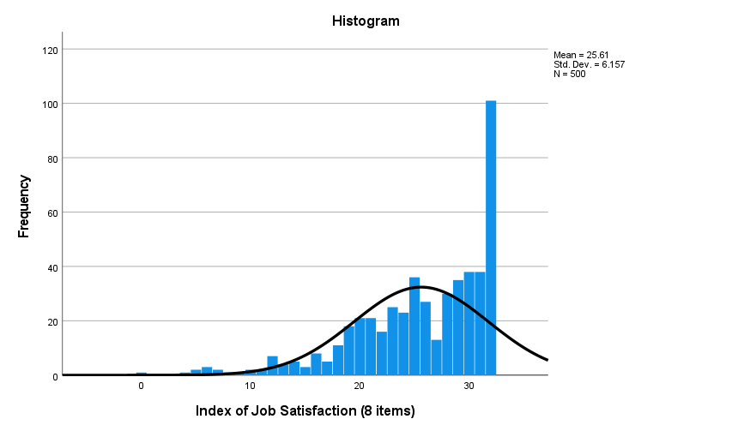

Figure 3: Job Satisfaction Index

***Bivariate Analysis***

***Research Question #4*: Do job positives, job stresses, and job satisfaction vary by demographic factors such as students’ gender, race and ethnicity, and first- or continuing-generation status? How do job positives and job stresses relate to job satisfaction? What factors improve job satisfaction?**

In order to gain a better understanding of the relationships between job positives, job stresses, and job satisfaction, we conducted a variety of tests to identify these relationships and the strengths of said relationships. First, however, we conducted tests between each Index (Job Positives, Job Stresses, and Job Satisfaction) and demographics. We then conducted tests to identify the relationships between the indexes and additional job-related factors.

*Job Positives Index and Demographics*

We conducted independent samples t-tests to compare the mean Job Positives Index scores of respondents based on race and ethnicity (binarized), gender (binarized), first- or continuing-generation, and international/domestic status as seen in Table 4. We utilized binarized race and ethnicity and gender data in order to have large enough groups to run valid statistical tests. We recognize this is problematic approach, but it was necessary for our situation and purposes.

**Table 4: Independent samples t-tests for Job Positives Index and demographics**

|  |  |  |  |  |
| --- | --- | --- | --- | --- |
| **Demographic and group** | **Group 1 Mean**  **Index Score** | **Group 2 Mean**  **Index Score** | **T-test score** | **p-value** |
| Gender (binarized):  1=female; 2=male | 17.75 | 17.71 | 0.107 | p>.05 |
| Generation:  1=First generation; 2=Continuing Gen. | 18.47 | 17.63 | 2.132 | p=.034 |
| International/domestic  1=International 2=Domestic | 17.97 | 17.78 | 0.391 | p>.05 |
| Race and Ethnicity(binarized)  1=BIPOC, including bi-/multi-racial/ethnic; 2=White | 18.47 | 17.56 | 2.551 | p<.05 |

We found no significant difference between the mean Job Positives Index scores by gender, (t(452) = 0.107, p>.05). The mean score for female respondents (m=17.75) is not significantly different from the mean Job positives Index score for male respondents (m=17.71). We also found no significant difference between Job Positives Index scores for International/domestic students (t(499) = 0.391, p>.05). The mean score for international students (m=17.97) is not significantly different from the mean score for domestic students (m=17.78).

We did, however, found a significant difference between the mean Index of Job Positives scores for first- and continuing-generation (p=.034, t=2.132). The mean score for first-generation students is 18.47 and the mean score for continuing-generation students was 17.63. There is a weak relationship between the Job Positives Index and generation. We also found a significant relationship between the Job Positives Index score and race and ethnicity (t=2.551, p=0.011). The mean score of BIPOC (Black, Indigenous, people of color) respondents (m=18.47, sd=3.298) is significantly higher than that of white respondents (m=17.56, sd=3.457). First-generation student workers tend to report more positive aspects of their job than continuing-generation students, and BIPOC students tend to report more positive aspects than their white counterparts.

We also conducted Spearman’s rho correlation coefficient tests to evaluate the relationship between Job Positives Index scores and year in school as well as GPA, as shown in Table 5. We found a weak, nonsignificant correlation between the Job Positives Index score and school year (r(500)=0.233, p=0.053). The p-value was extremely close to the cutoff for significance (p<0.05), but it still exceeded the cutoff. School year is not related to job positives score. We did, however, find a small, positive, significant correlation between the Job Positives Index score and GPA (r(196)=-0.142, p=0.001). Students who experience higher job positives such as being able to do homework or feeling like they are doing meaningful work tend to have a higher GPA.

**Table 5: Spearman’s rho tests for Job Positives and Demographics Bivariate Analysis**

|  |  |  |
| --- | --- | --- |
| **Variable** | **Spearman rho score** | **p-value** |
| Year in School | 0.233 | p>.05 |
| GPA | -0.142 | p<.001 |

*Job Positives Index and Additional Job-Related Factors*

We conducted Spearman rho correlation coefficient tests to evaluate the relationships between Job Positives Index score and engagement, overall satisfaction (the single item), and Job Satisfaction Index scores, as shown in Table 6.

**Table 6: Spearman’s rho tests for Job Positives Index x Other Factors Bivariate Analysis**

|  |  |  |
| --- | --- | --- |
| **Variable** | **Spearman rho score** | **p-value** |
| Engagement | 0.152 | p<.01 |
| Overall Satisfaction | 0.115 | p<.01 |
| Job Satisfaction Index | 0.173 | p<.001 |

We found a weak but significant positive correlation between engagement and Job Positives Index (r(504)=0.152, p<0.001), indicating a relationship between these two variables. Students who have higher levels of engagement at their job tend to have higher Job Positives Index scores. We also found a weak positive correlation between Job Positives Index scores and overall job satisfaction (r(502)=.115, p=0.01), indicating a significant linear relationship between the two variables. Students who report more positive aspects of their job tend to feel more satisfied with their job overall. Similarly, we found a weak positive correlation between Job Positives Index scores and Job Satisfaction Index scores (r(492)=.173, p<0.001), indicating a significant linear relationship between the two variables. Students who report more positive aspects of their job tend to feel more satisfied with their job. Students who experience more job positives are more likely to experience job satisfaction. This can be seen through engagement and overall satisfaction as well as the job satisfaction index. These findings align with those of Alarcon and Edwards (2010) who demonstrated that engagement is a positive factor in work and burnout is a negative factor, both of which contribute to job satisfaction.

*Job Stresses Index and Demographics*

To compare the Index of Job Stresses (Table 7) scores across the demographics of gender, generation, international/domestic status, and race and ethnicity, we conducted a series of Mann-Whitney U tests, but with no statistically significant results. We found no significant difference (p>.05) between Job Stresses Index scores of BIPOC students and white students. The mean score of BIPOC students was 4.12 while the mean score for white students was 4.28. We also found no significant relationship between the Index of Job Stresses and gender (p> .05) with the mean index of stresses in female students at 4.39 and the mean index score of stresses in male students ar 4.06. Similarly, we found no significant relationship between the Index of Job Stresses and international/domestic status (p> .05), with the mean score for international students at 4.28 and the mean score for domestic students at 4.27. Finally, we found no significant relationship between the Index of Job Stress and generation (p> .05), with the mean score for first-generation students at 4.12 and the mean score for continuing-generation students at 4.30. These results indicate that students do not tend to experience more or less job stress based on the social categories we tested.

**Table 7: Mann-Whitey U tests for Job Stresses Index and binarized demographics**

|  |  |  |  |  |
| --- | --- | --- | --- | --- |
| **Demographic and group** | **Group 1 Mean**  **Index Score** | **Group 2 Mean**  **Index Score** | **Mann Whitney U Test** | **p-value** |
| Gender (binarized):  1=female; 2=male | 4.39 | 4.06 | 18221.500 | p>.05  .219 |
| Generation:  1=First generation; 2=Continuing Gen. | 4.12 | 4.30 | 18264.500 | p>.05  .249 |
| International/domestic  1=International 2=Domestic | 4.28 | 4.27 | 12409.500 | p>.05  .708 |
| Race and Ethnicity(binarized)  1=BIPOC, including bi-/multi-racial/ethnic; 2=White | 4.12 | 4.28 | 21301.000 | p>.05  .530 |

We also calculated Spearman rho correlation coefficients for the relationships between Job Stresses Index scores and parent education, school year, and GPA, as shown in Table 8. We found no significant relationships between the Job Stresses Index and parent education (r(505)=.077, p>.05), school year (r(505)=.077, p>.05), or GPA (r(501)=-.065, p>.05). In sum, there is no significant relationship between any of the demographics we measured and students’ scores on the Job Stresses Index.

**Table 8. Spearman’s rho tests for Job Stresses Index and demographics**

|  |  |  |
| --- | --- | --- |
| **Variable** | **Spearman rho score** | **p-value** |
| Parent Education | -.009 | p>.05 |
| Year in School | .077 | p>.05 |
| GPA | -.065 | p>.05 |

*Job Stresses Index and Additional Job-Related Factors*

We calculated Spearman rho correlation coefficients for the relationship between the Job Stress Index (JSI) and the variables listed in Table 6 and found statistically significant relationships in all three cases. We found a moderate, positive, significant correlation between JSI and engagement at work (r(509)=.322, p<.001), a weak negative relationship between Job Stresses Index and overall satisfaction (r(509)= -.379, p<.001), a weak negative correlation between Job Stress Index and meaningful work (r(506)= -.256, p<.001), and a moderate negative correlation between Job Stresses Index and Job Satisfaction Index (r(496)= -.429, p<.001).

**Table 9: Spearman rho tests for Job Stresses Index and Factors of Job Satisfaction**

|  |  |  |
| --- | --- | --- |
| **Variable** | **Spearman rho score** | **p-value** |
| Engagement | .322 | p<.001 |
| Overall Satisfaction | -.379 | p<.001 |
| Meaningful Work | -.256 | p<.001 |
| Job Satisfaction Index | .429 | p<.001 |

The relationships between the Job Stresses index and the variables of overall job satisfaction point to the impacts that job stressors have on students' overall job satisfaction. When job stressors are lower, engagement while at work, overall satisfaction, and job satisfaction are higher. This is unsurprising. As Alarcon and Edwards (2010) noted from prior research, engagement, dedication, and absorption are all significant predictors of job satisfaction.

Job stresses may exist in any job due to various factors such as unavoidable events that are out of an employee’s control. College and university student employers can only work to improve factors *within* jobs such as supervisor relationships and the work environment in order to improve job positives like engagement and overall job satisfaction.

*Job Satisfaction Index and Demographics*

We conducted a series of Mann-Whitney U tests to compare the mean Job Satisfaction Index scores across the demographic characteristics provided by respondents in the survey, as shown in Table 10 below. The results of these tests show that race and ethnicity, gender, international/domestic status, and first-/continuing-generation status are not related to students’ satisfaction with their St. Olaf campus jobs.

Table 10: Mann-Whitney U tests for Job Satisfaction Index and Demographics

|  |  |  |  |
| --- | --- | --- | --- |
| **Demographic and group** | **Group 1**  **Mean Index Score** | **Group 2**  **Mean Index Score** | **p-value** |
| Race and ethnicity  1=BIPOC 2=white | 25.83 | 25.69 | p>0.05 |
| Gender (binarized)  1=male 2=female | 26.19 | 25.33 | p>0.05 |
| International/Domestic  1=International 2=Domestic | 26.29 | 25.57 | p>0.05 |
| First-/Continuing-Generation  1=First 2=Continuing | 25.80 | 25.64 | p>0.05 |

We also calculated Spearman’s rho correlation coefficients for the relationships between Job Satisfaction Index scoewa and non-binarized demographic characteristics of respondents, as shown in Table 11 below.

**Table 11: Spearman Rho test for Job Satisfaction Index and Demographics**

|  |  |  |
| --- | --- | --- |
| **Variables** | **Spearman rho score** | **p-value** |
| School year | 0.113 | p<0.05 |
| Parent education | -0.033 | p>0.05 |

We found a weak-to-moderate positive correlation (r(496)=.113, p<0.05), indicating a significant linear relationship between job satisfaction and class year. Student workers in higher years (e.g., seniors) tend to score higher on the Job Satisfaction Index. We found a weak, nonsignificant correlation (r(493)=-.033, p=0.463), indicating no linear relationship between job satisfaction and level of parent education. Highest level of parents’ education is not related to students’ satisfaction with their job.

*Additional Job-Related Factors*

We calculated a series of Spearman rho correlation coefficients for relationships between the Job Satisfaction Index and individual factors from Job Stresses and Job Positives, as shown in Table 12 below.

**Table 12: Spearman Rho tests for Job Satisfaction Index and Stresses/Positives Factors**

|  |  |  |
| --- | --- | --- |
| **Job Stresses/Positives Factor** | **Spearman rho score** | **p-value** |
| Engagement (feeling *un*engaged) | -0.581 | p<0.001 |
| Burnout | -0.310 | p<0.001 |
| Exhaustion after work | -0.328 | p<0.001 |
| Excitement (*lack* of excitement) | -0.580 | p<0.001 |
| Busywork | -0.258 | p<0.001 |
| Contributions are valued | 0.485 | p<0.001 |
| Self-direction | 0.418 | p<0.001 |
| Doing homework | 0.178 | p<0.001 |

We found a moderate negative correlation between Job Satisfaction Index scores and engagement (r(497)=-.581, p<0.001), burnout (r(497)=-.310, p<0.001), exhaustion after work (r(497)=-.328, p<0.001), indicating significant linear relationships between job satisfaction and each variable. Engagement was reverse-coded in our analysis, so a higher number refers to feeling less engaged. As students feel less engaged at work, their job satisfaction tends to decrease. Also, as students’ levels of burnout and exhaustion due to their student job increase, their job satisfaction tends to decrease. Our calculations resulted in a strong negative correlation with excitement (r(496)=-.580, p<0.001), and was also reverse-coded. Therefore, as students’ excitement to go to work increases, job satisfaction increases. We found moderate positive correlations between job satisfaction and valued contributions (r(499)=.485, p<.001) and self-direction (r(497)=.418, p<.001), indicating that students who feel that their contributions at work are highly valued are more likely to be satisfied with their job, as are students who experience more frequent opportunities for self-direction at work. Results also show a moderately weak negative correlation with busywork (r(495)=-.258, p<0.001) and a weak positive correlation with being able to do homework at their job (r(495)=.178, p<0.001), indicating that students who report completing busywork at their job on campus tend to be less satisfied with their job and students who can frequently work on their homework tend to be more satisfied with their job. These results are unsurprising.

**Job Category Bivariate Analysis**

We conducted a series of tests in order to examine the relationship between Job Category and our three indexes (Job Positives, Job Stresses, and Job Satisfaction). Students’ focus jobs could fit into one of five job categories: Educational, Student Services, Special Skills, Administrative, and Food Service.

*Job Category and Job Positives Index*

In order to assess the relationship between job category and Job Positives Index scores, we ran a series of one-way ANOVA tests (shown in Table 13 below) and found statistically significant (p<.05) differences in means between some groups but not others: Educational versus Special Skills and Administrative; Student Services versus Administrative; Special Skills versus Educational and Administrative; Administrative versus all four other categories; and Food Services versus Administrative. Students working in Administrative jobs (m=18.96) reported the highest average scores on the Job Positives Index while students in Special Skills reported the lowest average scores (m=16.05), followed closely by Food Services (16.75).

**Table 13: Job Category and Job Positives Index Score**

|  |  |  |
| --- | --- | --- |
| **Job Category** | **Mean Job Positives**  **Index Score** | **s.d.** |
| Educational | 17.68 | 3.395 |
| Student Services | 17.11 | 2.938 |
| Special Skills | 16.05 | 3.220 |
| Administrative | 18.96 | 3.256 |
| Food Services | 16.75 | 3.851 |

*Job Category and Job Stresses Index*

A series of one-way ANOVA tests showed statistically significant differences (p<.05) in the mean of Job Stresses Index scores across job categories (Table 14). Students working in Special Skills jobs reported the lowest average score on the stress index (m=3.64) while students working in Food Services reported the highest job stresses score (m=6.47). Students who work in Food Services tend to experience the most job stress while students who work in Special Skills tend to experience the least.

**Table 14: Job Category and Job Stresses Index Score**

|  |  |  |
| --- | --- | --- |
| **Job Category** | **Mean Job Stresses Index (3 items) Score** | **s.d.** |
| Educational | 4.08 | 2.290 |
| Student Services | 4.08 | 2.279 |
| Special Skills | 3.64 | 2.263 |
| Administrative | 3.99 | 2.579 |
| Food Services | 6.47 | 2.959 |

*Job Category and Job Satisfaction Index*

We used a Kruskal-Wallis H-test to compare the mean scores of job satisfaction for different job categories (Table 15). A significant difference was found (H(4)=63.141, p<0.001). Students working in Special Skills (m=28.18) reported the highest average scores on the index, with students working in Student Services, Educational jobs, and Administrative jobs following closely behind, while students working in Food Services reported much lower average scores (m=18.12).

**Table 15: Job Category and Job Satisfaction Index Score**

|  |  |  |
| --- | --- | --- |
| **Job Category** | **Mean Job Satisfaction Index (8 items) Score** | **s.d.** |
| Educational | 25.92 | 5.619 |
| Student Services | 26.45 | 4.993 |
| Special Skills | 28.18 | 4.052 |
| Administrative | 26.25 | 5.674 |
| Food Services | 18.12 | 7.384 |

When considering our results regarding aspects of job satisfaction such as engagement, flexible hours, being able to do homework on the job, and having positive relationships with coworkers and supervisors, it is reasonable to conclude that students who work in food services experience these factors the least out of all job categories. While the prior studies we reviewed did not address low job satisfaction among college student food service workers, our focus group and open-ended survey question enabled us to gather data on how students who work in food services feel about their jobs. They commented on low wages, poor training and the lack of staffing. Students also offered insight into what being a student worker in the cafeteria is like, citing physical demands and being overworked. For example, in response to a question about why they would not recommend their food service position to another student, one respondent wrote,

“*It is very physically demanding for a work-study job, and I don't have the opportunity to get my work done like people with desk jobs do, even though I am paid the same amount. With so few Stav workers this year, I am expected to do around 3 people's work each shift, because there aren't enough workers, but we have the same demand of students needing to eat.”*

**Conclusion and Recommendations**

Our research yielded several important findings. Our analyses indicate that about three-quarters of St. Olaf student workers tend to feel generally satisfied with their jobs. They cited scheduling flexibility, meaningful work, positive work environments, and self-direction as strong influencing factors. We found that students who experience frequent job positives like engagement and excitement tend to be more satisfied with their jobs. Additionally, students who experience more job stresses such as burnout, exhaustion, and busy work tend to have less job satisfaction than students who experience lower levels of job stresses. Across all job categories on campus, students working in Food Services score significantly lower on job satisfaction than those working in all other job types, and students in higher class years tend to have higher levels of job satisfaction than students in lower class years.

*Strengths and Limitations*

There were several notable strengths of our study. First, our response rate was high enough to generalize to the entire population of student workers at St. Olaf College. Additionally, our methods gleaned quantitative data from the closed-ended survey questions and qualitative data from the open response questions and our focus group. Finally, our research is currently very relevant to St. Olaf College – in the midst of the COVID-19 pandemic, the institution is experiencing significant staffing shortages for many student work positions (along with the United States as a whole). This situation has likely spurred students to think more about student work, potentially strengthening their ability to reflect on their own experiences.

Our research also had several limitations. Our research team is relatively demographically homogeneous as it is made up of three white, female researchers. This could have led to subjective blind spots in our research questions and analyses, though we tried to limit subjectivity in our study through our review of literature and our careful use of valid and reliable measures. Additionally, our research was conducted at a small, private, liberal arts college in the American Midwest whose student body is primarily white. Our study would have been strengthened by a more diverse and robust sampling population. Finally, we relied on voluntary survey responses to comprise our data, leaving room for bias as self-selected respondents tend to be more likely to have strong opinions than randomly selected respondents.

*Recommendations*

Based on our results, we have three recommendations for the school to consider regarding student employment on campus and job satisfaction. These aim to promote higher student job satisfaction and thus lower turnover in student-worker jobs:

1. Evaluate current pay and work imbalance in busy, manual labor jobs. Higher pay and/or increased benefits would improve the satisfaction of students in these positions.
2. Allow students more flexibility when it comes to scheduling and tasks (i.e., increased ability to take work off for academic reasons). This increase in flexibility and self-direction will provide students with a much more balanced student employment experience.
3. Hire non-student staff for food service positions and open up more positions in other job categories for student workers such as student services, administration, and education. This will allow more students to have satisfying employment.

**Works Cited**

Agho, G. O., C.W. Mueller, and J.L. Price. 1993. Determinants of employee job satisfaction: An empirical test of a causal model. Human Relations, 46(8): 1007-1027.

Alarcon, Gene M. and Jean M. Edwards. 2010. The relationship of engagement, job satisfaction and turnover intentions. Journal of the International Society for the Investigation of Stress: e293-e298.

Creed, Peter A., Michelle Hood, and Shi Hu. 2020. "Job crafting by students who work and study." International Journal for Educational and Vocational Guidance 20.2: 331-349.

D’abate, Caroline P., et al. 2009. “Making the Most of an Internship: An Empirical Study of Internship Satisfaction.” Academy of Management Learning & Education, 8(4):527-539.

McNall, Laurel A., and Jesse S. Michel. 2011. "A dispositional approach to work–school conflict and enrichment." Journal of Business and Psychology 26.3: 397-411.

Neuman, W. Lawrence. 2012. Basics of Social Research: Qualitative and Quantitative Approaches. Boston, MA: Pearson.

Nuñez, Anne-Marie, and Vanessa A. Sansone. 2016. “Earning and learning: Exploring the meaning of work in the experiences of first-generation Latino college students.” The Review of Higher Education 40.1: 91-116.

Tessema, Mussie T., Kathryn J. Ready, and Marzie Astani. 2014. "Does part-time job affect college students' satisfaction and academic performance (GPA)? The case of a mid-sized public university." International Journal of Business Administration 5.2: 50.

Wyland, Rebecca et al. 2016 “An Examination of the Relationship Between the Work–School Interface, Job Satisfaction, and Job Performance.” Journal of business and psychology 31.2: 187–203.

**Appendix A: Additional Figures and Results**

**Table 16: Job Positives Index Frequencies**

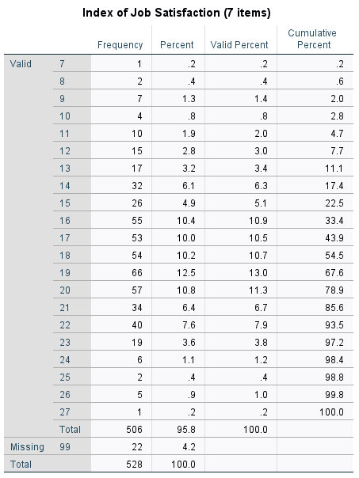

**Table 17: Job Stresses Index Frequencies**

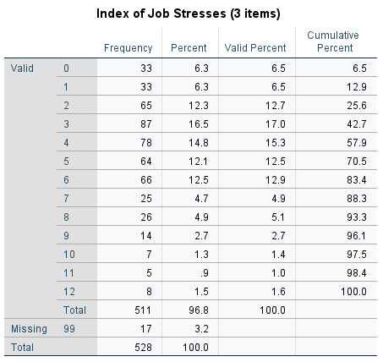

**Table 18: Job Satisfaction Index Frequencies**

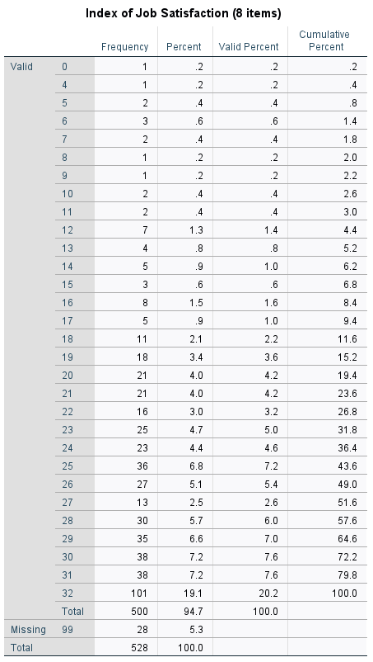

**Appendix B: Survey Questions and Response Categories**

Questions about Job Stresses: How Often do you experience these things in relation to your St. Olad “focus job”?

**Questions:**

* Question 1: I feel “engaged” at work (positive and fulfilled).
* Question 2: I experience “burnout” at my job (such as feelings of exhaustion, cynicism, and reduced effectiveness at work).
* Question 3: I feel excited to go to work.
* Question 4: I feel exhausted before I begin my work shift.
* Question 5: I feel exhausted when I leave work.
* Question 6: My job requires a lot of physical labor.
* Question 7: My job requires a lot of mental labor.
* Question 8: I have to do “busy work” at my job (work that keeps me occupied but has little value).

**Possible Responses:**

* Always or almost always
* Most of the time
* Sometimes
* Seldom
* Never or almost never

Questions about Job Positives): How often do you experience these things in relation to your St. Olaf “focus job”?

**Questions:**

* Question 1: I feel valued for my contributions at work.
* Question 2:I have the opportunity for self-direction at work.
* Question 3:My job allows me to work on my own with little immediate supervision.
* Question 4:My job allows me to make decisions about tasks (such as about which tasks are most important and the order in which I will do them).
* Question 5:My job allows me to do homework while I am on the job.

**Possible Responses:**

* Always or almost always
* Most of the time
* Sometimes
* Seldom
* Never or almost never

Questions about Job Satisfaction: Thinking about your St. Olaf “focus job”, please indicate your level of agreement or disagreement with each statement below.

**Questions:**

* Question 1: Overall, I feel satisfied with my job.
* Question 2: My job is flexible in terms of the number of hours I work.
* Question 3: My job is flexible in terms of which days and times I work(separate from the number of hours).
* Question 4: My job enhances my experience as a St. Olaf student.
* Question 5: My work is meaningful to me.
* Question 6: I would rather work at a different job.
* Question 7: If I could, I would quit my job.
* Question 8: I would recommend my job to another student.

**Possible Responses:**

* Strongly agree
* Somewhat agree
* Neutral
* Somewhat disagree
* Strongly disagree