How to Create a Student Employment Job Posting:

- Go to this website: https://www.stolaf.edu/apps/stuwork/
- Click “Add/Edit Job Postings” from the tool bar
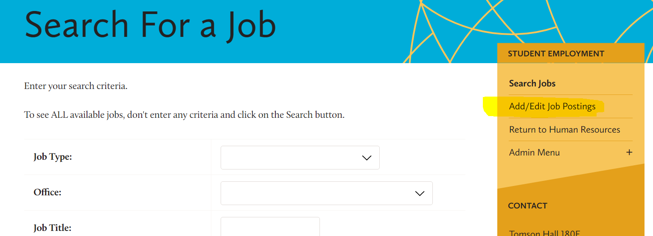
- Use your St. Olaf credentials on the Administrative Login page
- Click “Add a New Job” at the bottom of the page
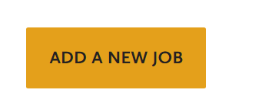
- This will open the blank job posting template. All items in red text are required fields that must be completed. However, please fill out as many fields as possible to provide as much information as we can to students
  - Job Title: this should be the same as what is on the position’s job description
  - Job Type: Be sure to select appropriate option from the drop-down menu
  - Office: Select the appropriate office. If you do not see your office, please email studentemployment@stolaf.edu.
  - Job Year: Select the appropriate option from the drop down
  - Hours/week: Pick the appropriate hours range from the drop down menu. If you would be willing to hire multiple students to fill the scheduling needs then select “Flexible”
  - Time of Hours: If there are specific shifts needed, please be sure to explain that here
  - Number of Available Positions: please put the appropriate number of available positions. If you are more flexible, leave this blank or put “multiple”
  - Appropriate for incoming/first year students: Some positions may not be appropriate for first year students. Please select yes/no in this field as appropriate.
  - Contact Person: Type in the first and last name of the contact person for the position. This should be the person best equipped to answer questions regarding the position. It does not have to be the supervisor.
  - Contact Email: Type in the UserID for the contact person’s St. Olaf email account. Do not put @stolaf.edu.
  - Phone Extension: Please put in the 4 digit office extension of the contact person.
  - Job Description: This is where the “Description of the Position” and “Duties and Responsibilities” sections of the job description can get copy and pasted.
  - Skills Needed: This is where the “Qualifications” section can get copy and pasted from the job description.
  - Additional Comments: Please provide any other relevant and helpful information for students.
  - How to Apply: Use what makes the most sense for your department/position. Most departments will either use a Google form, ask for resumes and/or cover letters, or ask for an email expressing interest. If you would like a standard student employment application Google form template, please email studentemployment@stolaf.edu
  - Hiring Time Line: Please fill this section out to the best of your ability. It is incredibly helpful for students to have an understanding of what to expect for positions they are applying for.
- When the posting template is complete, please click 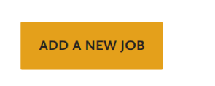
- Your job postings is now live! Please remove the posting when you have finished hiring. To remove the posting follow the steps below to Edit but at the last step, select “Delete Job”

How to Edit a Student Employment Job Posting:

- Go to this website: https://www.stolaf.edu/apps/stuwork/
- Click “Add/Edit Job Postings” from the tool bar
- Use your St. Olaf credentials on the Administrative Login page
- Find your job from the list of postings and click on the job title

- Select “Update Job” when complete
