AdOBE SIGNATURE INSTRUCTIONS

To use your actual signature:
Sign a white piece of paper and take a picture, you can use your phone and email it to yourself, save it on your computer or you will have the option to use your web cam- to take the picture. Save this somewhere you will find it again.
Save your document as a PDF on your computer.
Go to place saved and open the PDF you saved.
Click on Fill & Sign:
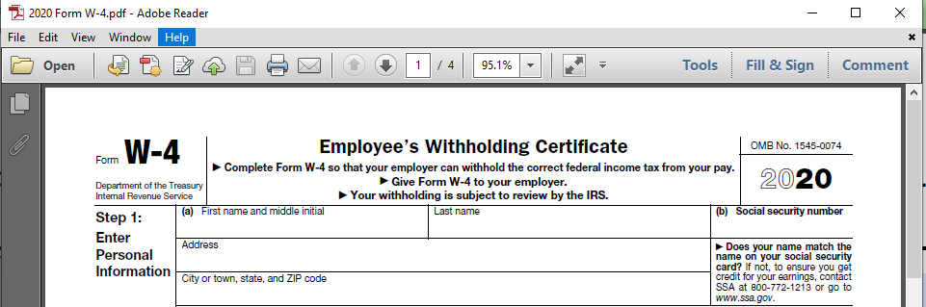
Then click Place Signature:
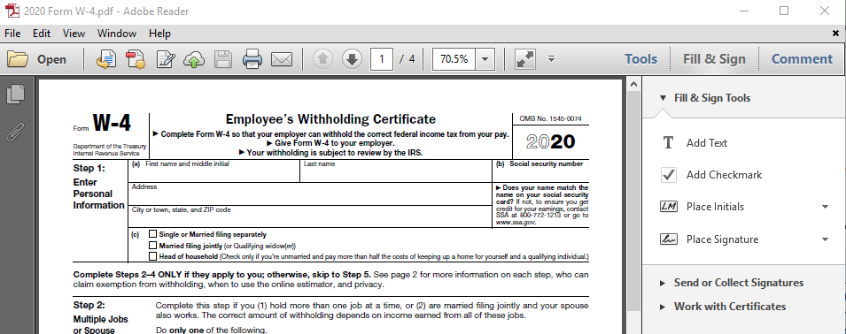
Use the drop down for Place Signature:
If you use a webcam you will need to sign a piece of paper to take the image.
You can use the saved image you may have done initially- use an image.

To use a certificate:

You would have elected this option in the step above.
Adobe will prompt you to draw the place you want to place your signature. Your options may differ slightly follow the prompts.

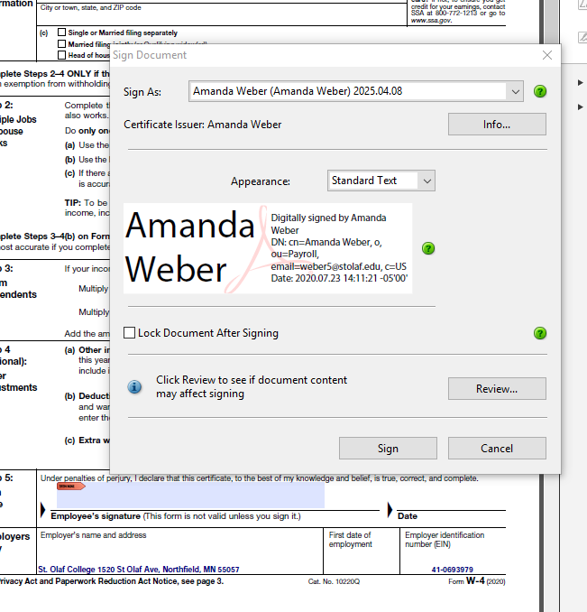
Click sign and it will also prompt you to resave the document.

