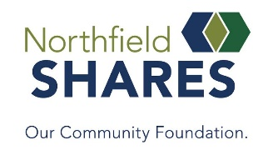
Our Community Foundation Assistant
Student Work/Internship Opportunity

Part Time
5-10 hours/week – depending on candidate
$15/hour
Begin January 2024 – end of school year
Primarily in office, but may have opportunity for remote hours
Position Summary
This position will support the staff and overall work of Northfield Shares, Our Community Foundation, with the with direction provided by the Executive Director.

Skills
Candidates should present:
- Attention to detail.
- Writing, computer, organizational and people skills
- Willingness to work in a professional setting.
- Willingness to learn from others yet work autonomously.
- Ability to do research.
- Experience with database use, Google platform, Microsoft programs
- Preferred: experience working in a database

Benefits
    - Able to work with a local, growing nonprofit organization.
    - Will learn the Community Foundation model and work on behalf of the Northfield area that will include, philanthropy, grant writing, database management, marketing, community engagement, volunteerism and more.
    - Will learn about other local nonprofit and community organizations.
Opportunity to attend Board of Directors meetings.
    - Work hours can be around class/lab schedule but between 9-5 to begin.
Roles and Responsibilities may come from:
- Cleanup of Organizational CRM data (merge records, data entry)
- Audit of CRM Fund accounts for all required documents, add as needed\
- Explore online giving options and connection to master database.
- Grant research and writing
- Article writing for website, e-newsletters, etc.
- General office help.
- Assist with Board of Directors meeting preparation.
- Learn and explore greater uses for the Volunteer HUB system.
Requirements
Work includes confidential information. Candidate will sign a Confidentiality agreement with the
Foundation.

Interested candidates should email their letter of interest with a one-page summary why they are interested in the position and what skills match the description to: info@northfieldshares.org Subject: Assistant Internship

